Job Description: Music Assistant (part-time)
Location:
Kingswood Senior School
Responsible to:
Director of Music
Job purpose:
- This role would be in addition to the role of Bath Abbey Assistant Organist
- To assist the Music Department in all aspects of its work, including individual and classroom support
- To promote organ playing and choral music throughout the Foundation
- Show commitment and contribute to all aspects of life in a busy boarding and day school, including the co-curricular music programme.

Department information
An education in Music at Kingswood prepares students for a cultural understanding and appreciation of the place of music in the modern world. Within the curriculum, we offer a broad range of activities that enables all students to fully develop their musical potential and interests. We also believe passionately that, through lessons, students will develop wider life skills such as creativity, self-confidence, thinking on-the-go, discipline and imagination.
With three academic staff (Director of Music – Mr Andy Barton; Teachers of Music – Mrs Elaine Francis & Mr Jamie Knights (also Musician in Residence)), a part time Music Administrator, Graduate Music Assistant and a team of 20 visiting instrumental staff, the department is well-placed to be able to support and challenge our musicians at all levels.
Music Curriculum
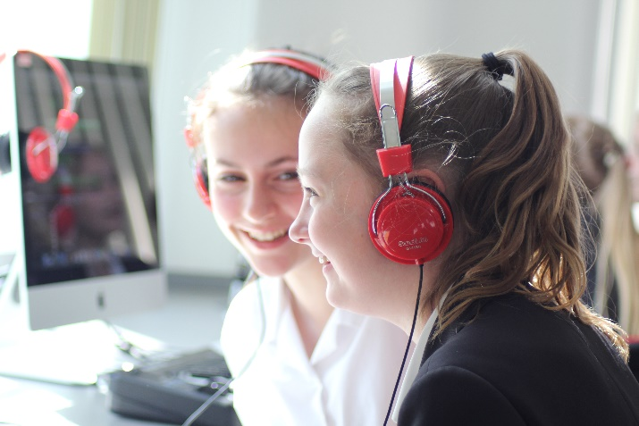
All Kingswood students study Music in Years 7 and 8, and it is also a very popular option in Year 9. Music is an equally popular subject at GCSE and A Level, and students regularly go on to courses at leading universities and conservatoires, often following this with top careers in the music business.
The broad curriculum in Years 7-9 instils the three aspects of performing, composing and listening & appraising. Students have the opportunity to play instruments and sing in lessons, as well as explore music technology, all whilst studying a wide array of topics.
The Music School provides a flexible space for teaching, with the opportunity to undertake regular whole-class and group performance work. Students are also highly encouraged to take up individual instrumental/vocal lessons.
The department has a strong record at GCSE and A Level, and alongside this, past and current students have been awarded places in the West of England Youth Orchestra and at the Junior Royal Welsh College of Music & Drama. Recent students have gone on to study Music at the Guildhall School of Music & Drama and the Royal Northern College of Music.
Instrumental/Vocal Lessons
The Music School provides space for individual musical tuition to take place within school working hours and there are currently over 300 lessons taking place each week. We are supported by an excellent team of 20 Visiting Music Teachers, delivering lessons on all main orchestral instruments, as well as piano, guitar, bass, drum kit and harp. Lessons take place on a rotation system, with fixed slots reserved for A Level students. ABRSM examination sessions are held termly, and students also undertake Trinity, Rock School and LCM exams at local centres.
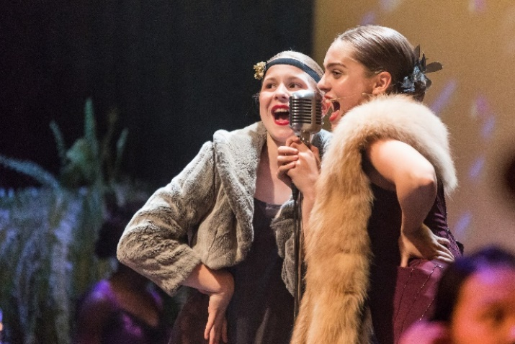
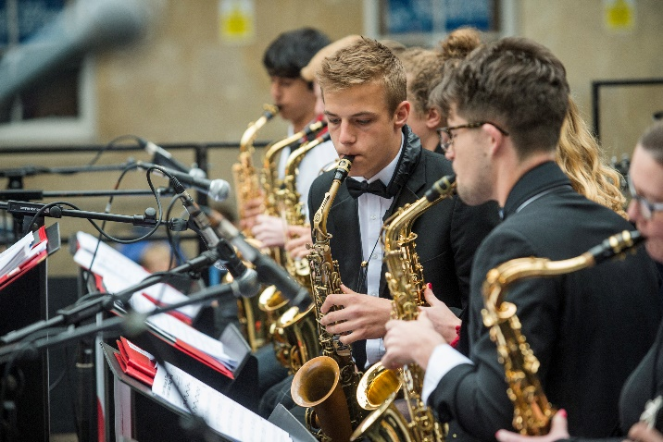
Co-Curricular Music

The co-curricular music provision at Kingswood is broad and inclusive, with ensembles to suit all ages and abilities. The Westwood students (Years 7 and 8) benefit from their own choir and orchestra, which feed into the school’s main Chamber Choir and Senior Orchestra. Alongside these foundation ensembles are Kingswood Strings, Kingswood Jazz Orchestra, Clarinet Ensemble and Brass Ensemble. These groups rehearse weekly and have regular concert opportunities each term. In addition to the annual Christmas and Spring Concerts, the department has a termly recital series, regularly undertakes concert engagements in and around Bath, and hosts specialist concerts throughout the year. A major highlight of the year is our annual showcase for Bath Festivals’ Party In The City. The choirs sing extensively and are a prime focus in the annual Carol and Commemoration Services. The musicians of Kingswood tour regularly, with the most recent tour to Holland taking place in July 2019 and plans to tour again in the summer of 2024. The foundation choirs recently recorded a Christmas album, Carols from Kingswood, raising significant funds for Action for Children.
The department also enjoys strong links with the Drama department, collaborating on Junior and Senior musicals and also celebrates achievements in the Performing Arts at the annual Music and Drama Awards. The Music and Drama departments stage musical productions, with the next being Little Shop of Horrors in February 2023.
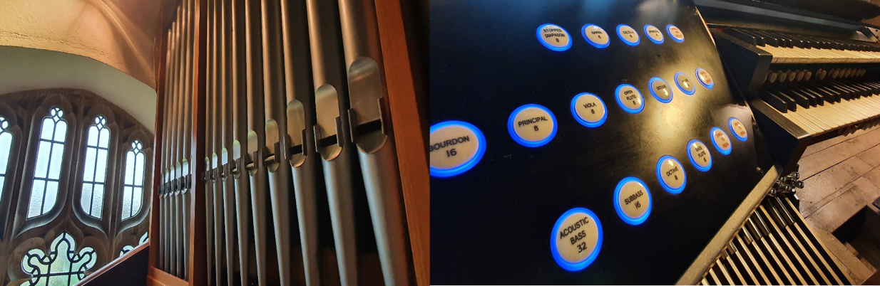
Accommodation and Resources
The department is housed in Kingswood’s Music School which features a large, flexible and open classroom space, as well as a separate Music Technology suite equipped with 15 Macs each running Logic Pro X and Sibelius. The Music School also features a dedicated studio for multitrack and live recordings, with an iMac, Focusrite Claret 8 PreX and an Icon QCon Pro. There is also a suite of practice rooms, a smaller project studio, staff room and offices for staff. The curriculum is enhanced by a wealth of resources, including a full Samba kit, classroom guitars and keyboards, xylophones and glockenspiels. The department also houses a Yamaha C1 in the Lower Classroom for recitals and examinations.
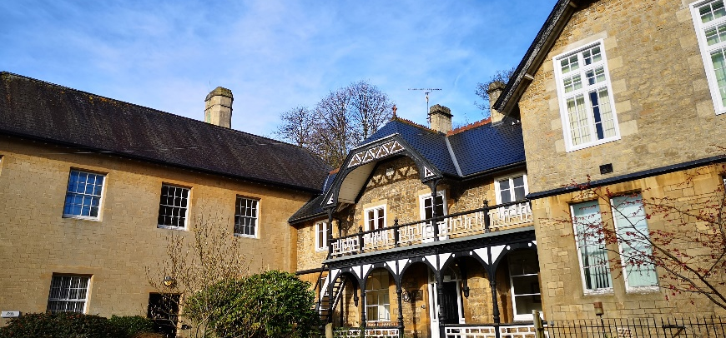
The musicians are also able to benefit from the 366-seat Kingswood Theatre which is used for weekly rehearsals and termly concerts, and is home to a Yamaha C7.
Beyond this, Kingswood’s Chapel is a space in much use for music and worship, and is home to a two manual Copley pipe organ which has recently been restored by Clevedon Organs, three manual Mackie digital organ, and a Kawai RX3 grand piano.
Music Scholarships
Music Scholars are awarded upon entry to the school in Years 7, 9 and 12 to students who show exceptional potential as young musicians. The scholars are offered a wide programme of development throughout their time at Kingswood and there are significant opportunities throughout the year for them to develop as performers.

Key duties & responsibilities:
Assisting the Director of Music to support the day-to-day running of the department, including the following:
Co-Curricular support
- Teaching the organ to Kingswood pupils who have been identified by the Director of Music, and preparing these students for exams and performances
- Rehearsing Summerhill Singers at Kingswood Prep School and leading them in performances and services
- Assisting with ensembles rehearsals in the Senior School department, primarily taking sectional choir rehearsals; playing/singing as required
- Accompanying when required

Organ & Piano Responsibilities
- Arranging for regular tuning and maintenance of the two manual Copley organ in Chapel, in discussion with the Director of Music
- Keeping the piano inventory and arranging for tuning maintenance as needed
- Liaising with the piano and organ tuners on behalf of the Director of Music

Concerts & Services
- Assist with the departmental organisation and preparation for concerts
- Assist at school concerts, productions or services as required
- Support and assist with trips and visits
- Support Chapel and Whole School Service music provision, in conjunction with the Musician in Residence

Academic & Student Support
- Music Scholar support through one-to-one sessions
- Individual GCSE/A Level support for composition and performance
- Individual performance technique and examination preparation for non-A Level Music students
- G & T and Study Support work as required
- Classroom assistance as required and based on the skills of the successful candidate, including GCSE and A Level

Additional Duties
- 1 evening per week 6.30 – 8.30pm in the Music School
- Attend weekly departmental meetings

The successful candidate will be expected to show commitment in contribution to the wider life of the school. Kingswood has a high reputation for its extensive co-curricular programme and all staff are expected to contribute to the programme as part of their regular school routine.
It should be noted that this is not a definitive list; your duties will be at least those listed above and will be tailored to the particular skills and strengths of the successful candidate.
You will be expected to:
- Conduct yourself with professionalism, tact and diplomacy at all times as a representative of Kingswood School.
- Observe health and safety procedures and work safely at all times
- To comply with all school policies and procedures including reporting any concerns to the appropriate person in relation to those covering child protection, health, safety, welfare, security, confidentiality and data protection.
The ideal candidate
Essential qualifications, experience and skills
You will have:
- A good degree in Music
- Very high level of organ proficiency
- Experience working with singers and leading vocal ensembles
- Experience in performing as a soloist and in ensembles and/or accompanying
- The ability to work effectively with young musicians
- A desire to be part of busy and successful department
- The ability to work independently and proactively, and as part of a team
- Strong organisational skills
- Effective communication and interpersonal skills and an ability to interact appropriately with others within the school community
- Good level of competence in ICT to support general administration
Preferable:
- Experience teaching young musicians on an individual basis
- Knowledge of Music ICT, such as GarageBand/Logic and Sibelius or similar
Key competencies
- Desire to share and contribute ideas
- Uphold and live the Kingswood values and ethos
- Commitment to equal opportunities and anti-discriminatory practice
- Flexible and with a ‘can-do’ attitude
- Supportive of the Christian ethos of the school
- Open to new ideas and practices
Terms and conditions
Hours are by negotiation to fit with Bath Abbey responsibilities, but may be up to 16.5 per week, during term time only (34 weeks). Please note, working hours may include evenings and some weekends.
Paid holiday entitlement is 5.6 weeks per annum, inclusive of bank holidays. No holiday may be taken during term time unless agreed with the Director of Music.
As an illustration, for 16.5 hours a week during term time only, the actual salary will be £9,892 per annum, inclusive of holiday pay (based on £31k FTE).
For a combined role at the Abbey and School, single accommodation may be available (reviewable on an annual basis). If accommodation is included, there would be the expectation of an evening duty in the Music School.
Please note that this role is being offered as an additional opportunity to the Assistant Organist role at the Abbey. If employment at the Abbey ceases, for whatever reason, the role at the School would not continue.

Child protection
It is your responsibility to help promote and safeguard the welfare of children and young persons for whom you are responsible, or with whom you come into contact, and to adhere to and ensure compliance with the School’s Child Protection Policy Statement at all times. If, in the course of carrying out the duties of the post, you become aware of any actual or potential risks to the safety or welfare of children in the school, you must report any concerns to the School’s Designated Safeguarding Lead. Protecting children from the risk of radicalisation is part of the School’s safeguarding duties (under the Prevent Duty).

Application process
If you are interested in taking on a role with both the Abbey and School, candidates should send their CV, a letter of application and fully completed Kingswood School Application Form to Huw Williams, Director of Music at the following email address: hwilliams@bathabbey.org
Deadline for applications: Friday 3 February 2023, 5pm.

Candidates will be informed if they have been short listed by Friday 10 February 2023.
Interviews and auditions will take place on Monday, 20 February 2023.

If you’d like to have an informal discussion about the role at Kingswood School in advance of applying, please contact the Director of Music abarton@kingswood.bath.sch.uk

