Visit to Austria for the Oberammergau Passion Play
Wednesday 22nd June to Wednesday 29th June 2022

The Friends of Bath Abbey invite you to register an interest in the above holiday to Austria for summer 2022, but with places open to all. The arrangements are being made through McCabe Pilgrimages who were responsible for a very successful similar visit for the last passion play in 2010. McCabe have made a firm allocation of places for a ‘Bath Friends’ group.

The half – board accommodation will be at the Inntalerhof Hotel, Mosern, in the Tyrol, except for one night in Oberammergau following attending the Passion Play. The itinerary is as follows:-

Wednesday – flight from Heathrow to Munich, coach to Mosern
Thursday – Scenic coach tour into the Pitztal valley, with a cable car ascent to a lake.
Friday – Travel to Oberammergau, arriving mid morning. Lunch included. Afternoon and evening attend the Passion Play with dinner included in the interval. Overnight in Oberammergau.
Saturday – Time to explore the village, return to the Tyrol in the afternoon via scenic route with visits en route.
Sunday – Free Day, opportunity to visit a local church or take a walk.
Monday – Full day excursion including Innsbruck and Stams Abbey. Tyrolean evening.
Tuesday – Mosern – local guided walk and free time
Wednesday – Afternoon return flight to Heathrow

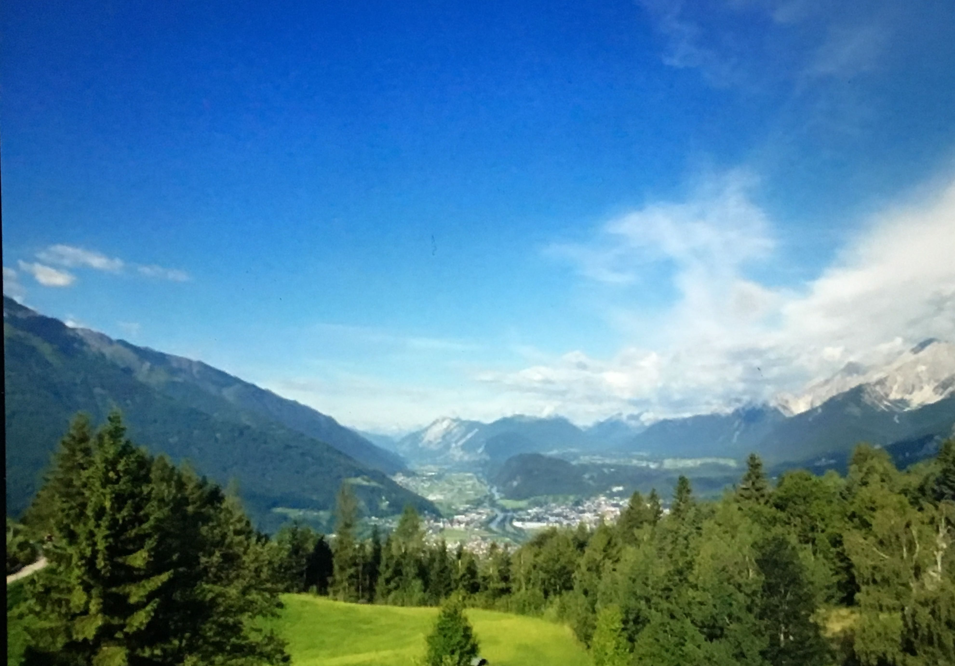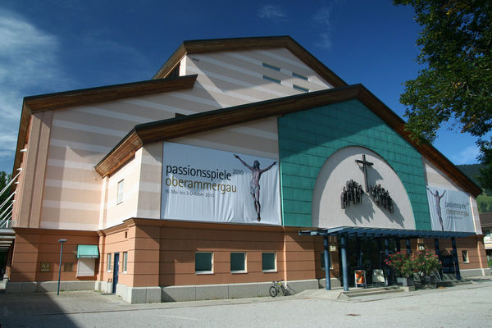
The view from the hotel The Passion Play Theatre

The basic cost is £1785 per person, and a few single rooms will be available at a supplement of £115. There may be some minor additional costs. However we will be able to provide a coach from Bath to Heathrow and return at no extra charge. Firm bookings are to be made direct with McCabe Pilgrimages including a £600 deposit (£400 returnable until 30th April 2021).

If you are interested in joining this visit, please inform Jeff Jupp tel. 01225 311390, email –jeff.jupp@btinternet.com, who will send you full details, including the booking form. Or post the slip below to Jeff at 21 Bloomfield Park, BATH, BA2 2BY
-------------------------------------------------------------------------------------------------------------------------------

Please register my interest in The Friends visit to Austria for the 2022 Oberammergau Passion Play.

Title________Name_____________________________________Address_____________________

_____________________________________________________Postcode____________________

Telephone___________________________Email________________________________________

