Footprint Project Update, July 2020

We do hope this newsletter finds you keeping well and in good spirits during these challenging times. We’d like to bring you up to date on progress with the Footprint Project and share some exciting developments.

Footprint Restarts Following Temporary Shutdown
We’re pleased to let you know that Footprint construction restarted on 27th April, following a shut-down on 27th March in response to the coronavirus pandemic. With the majority of the Footprint contractors now back on site, albeit in a much-reduced workforce, the flow of work continues to depend heavily on the Covid-19 safety measures which are currently in place, as well as the stability of the supply chain. Although there has been slower progress due to the coronavirus working restrictions, we are currently on track for opening Footprint to the public in summer 2021.

Footprint Focus
South Nave and South Aisle / Jackson Extension
Work has focused on priority areas such as the Jackson Extension (which will house the new Discovery Centre), and the conservation of the historic ledgerstones in the Abbey’s South Aisle and South Nave. The final ledgerstones were lifted in mid-June and are being repaired by our specialistic conservation partners, Sally Strachey Historic Conservation, ready for re-laying in the autumn. Work in the Jackson Extension will continue over the remainder of this year to allow the fit-out of the Interpretation scheme in summer 2021.

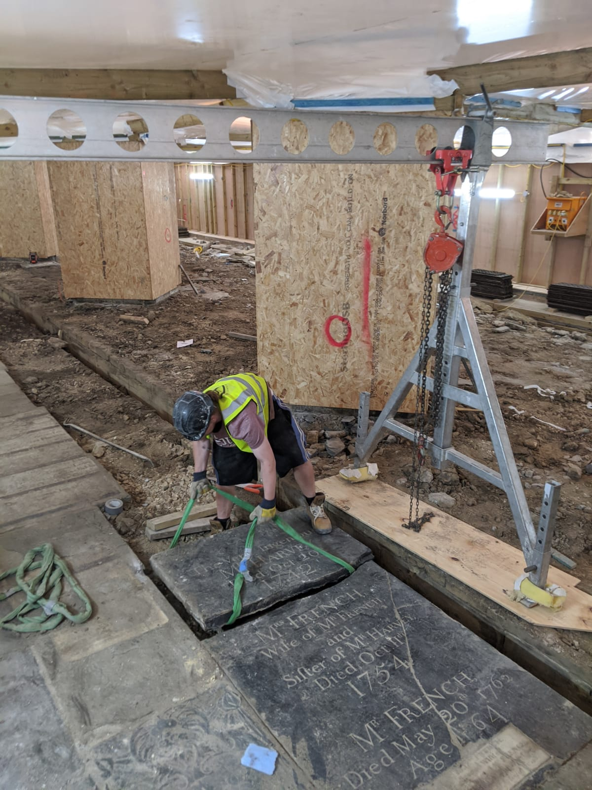
Footprint’s specialist partners, Sally Strachey Heritage Conservation (Left), working diligently in the South Nave to raise the historic ledgerstones. Whilst SSHC repair and conserve the raised ledgerstones, the South Nave floor will be excavated and the eco-friendly Heat Recovery System will be installed. Once this work is completed, the ledgerstones will be re-laid in autumn 2020.

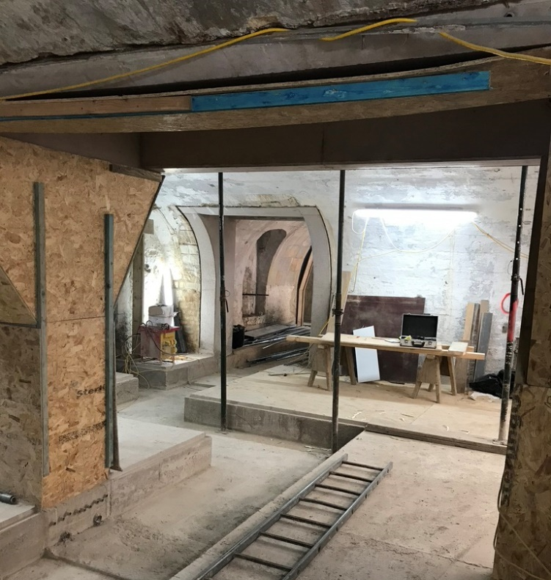
The new Discovery Centre (Right), situated in the Vaults beneath the Abbey’s Jackson Extension, continues to take shape.

Kingston Buildings – New Song School, Volunteers’ Room and Staff Offices
Work is progressing well in Kingston Buildings, the row of Georgian terraced houses adjacent to the Abbey, which are being transformed into the new Song School, volunteers’ room and staff offices. The corridor which leads to the new Song School is being completed (Left, below), and specialist carpenters are now fitting the Song School’s timber wall panelling, balustrades and acoustic fittings (Right, below). These spaces will be fitted out and ready for occupation by the end of 2020.

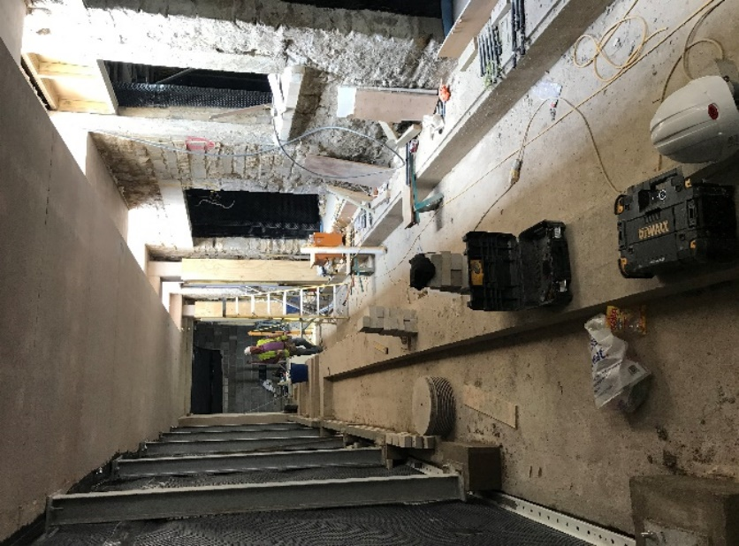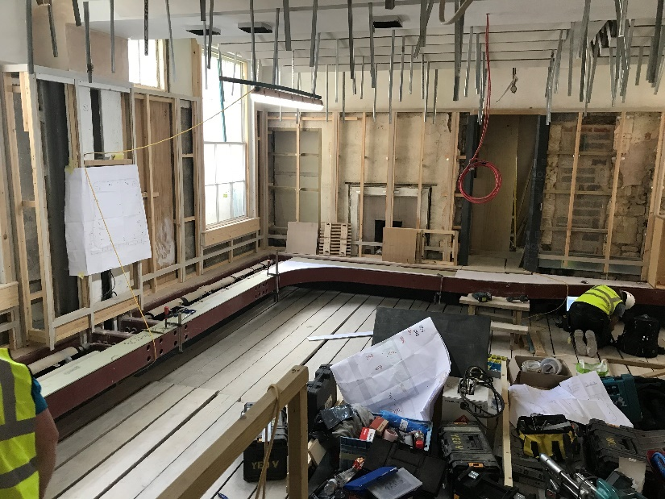

The Vaults – New Learning Space, Kitchen and WCs
Work is progressing well within the vaults beneath Kingston Parade. These areas will become the new Learning Space, kitchen and WCs. These historic vaults have been opened up to create the new spaces and we now have a real sense of how these rooms will look and feel.

Eco-Friendly Underfloor Heating System
The Abbey’s new heating system, which uses energy from Bath’s famous hot springs, is one of the most innovative aspects of the Footprint Project. We are preparing the final details for the installation of the new heat exchangers to the Roman Great Drain, which is located 7m below York Street. This innovative system will use a series of energy blades to draw energy from the natural hot spring waters that flow from the Roman Baths towards the river, ensuring that we have a sustainable and efficient method of heating the Abbey.

We have been laying more pipework outside the Abbey and the new plant room is complete. When we install the heat exchangers at the end of the building contract, the Abbey will receive around 50% of its energy from a renewable source, which is a fantastic environmentally friendly use of this natural resource. At the same time, we are continuing to upgrade the Abbey lighting with energy-efficient LED fittings, along with new electrical and data services to ensure we maximise the flexibility of the Abbey floor for future events, concerts and presentations.

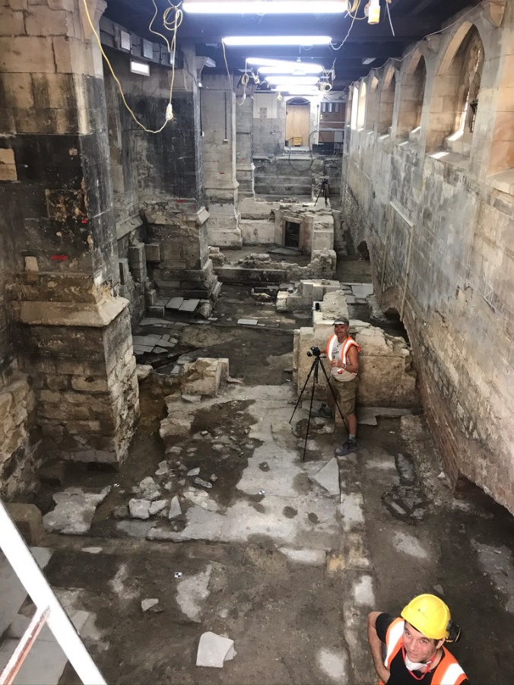
Excavation in Bath Abbey’s Jackson Extension has revealed Georgian houses, Norman construction and sections of the Cloister floor.
In the image (Left) we see colleagues from Wessex Archaeology, Footprint’s archaeological partners, surveying the discoveries.

Archaeological Discoveries
Archaeology continues to be carefully managed, and exciting discoveries continue to be uncovered. Whilst excavating within the Abbey’s South Aisle, we have uncovered the carved footings of the Norman Abbey and a large collection of beautiful marble memorials, which were unceremoniously discarded during the Victorian renovations. Whilst excavating the Abbey’s Jackson Extension, we have uncovered examples of Georgian houses, Norman construction and sections of the Cloister floor, along with the maker’s mark of William Vertue – Master Mason to Henry VIII.

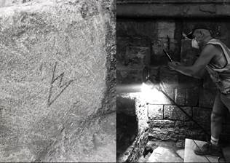
Discovered during excavations to the Abbey’s Jackson Extension – the maker’s mark (Left) of William Vertue, Master Mason to Henry VIII.

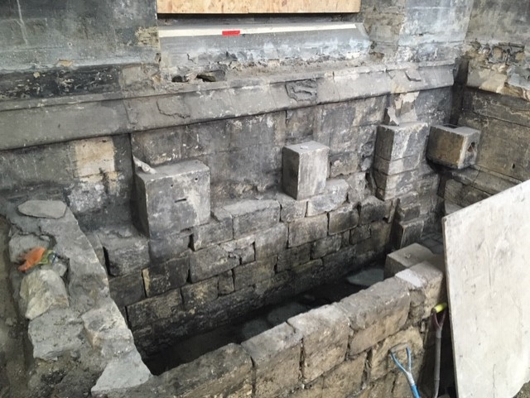
Norman stonework discovered beneath the door to Bath Abbey’s Nave.

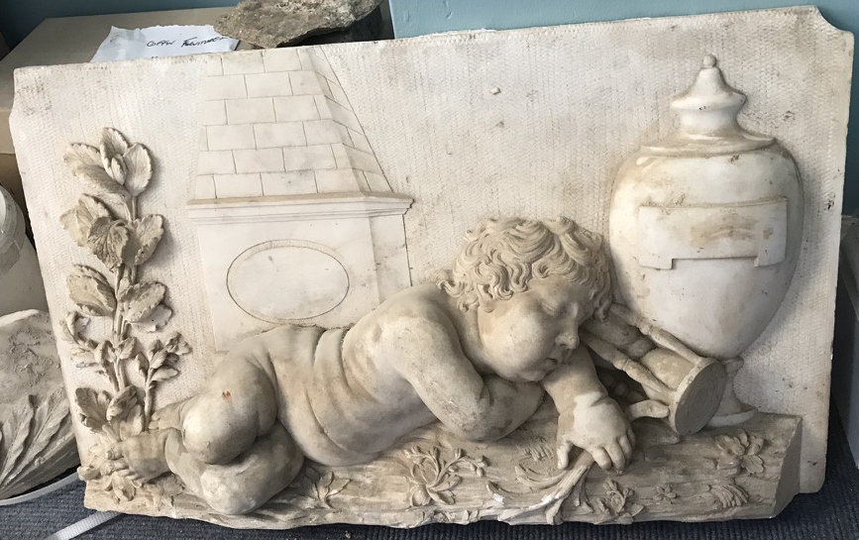
A beautiful marble memorial fragment (Right), in the shape of a cherub, discovered beneath the Abbey’s South Nave. Research is underway to identify the origins of this stunning memorial.

With every new discovery across the site, we are able to further develop our understanding and build the story of the development and history of Bath Abbey.

The Footprint Vision for Our Community
As our communities rebuild after the ravages of the coronavirus pandemic, the Footprint vision has become even more necessary. Bath Abbey – reimagined through Footprint – will embrace everyone within the inspirational Abbey Family, be they local, national or international, extending a warm welcome to all and an invitation to engage with exciting education opportunities and accessible learning spaces, encounters with dynamic interpretations of the Abbey’s rich heritage, stimulating opportunities to volunteer, and a commitment to environmental innovation and stewardship – all taking place within a vibrant hub for Christian worship and mission.

Footprint will transform Bath Abbey, and a transformed Bath Abbey is a vital component in the renewed future of our community.

Supporting Footprint
In these challenging times, we must continue fundraising to make sure we deliver the ambitious Footprint vision to its fullest extent and develop all the wonderful opportunities Footprint can bring to our community.

If you are able to support Footprint with a monetary gift, we would deeply appreciate your generosity. All donations will be acknowledged by personal letter and, if you so wish, your name will be added to the Benefactors’ Book which will be displayed in the new Discovery Centre.

The Brownsword Charitable Foundation is match-funding donations up to a total of £64,000, meaning that any donation you make will be doubled and have twice the impact on Footprint. For a confidential discussion about supporting Footprint, get in touch with Cath Foxwell, our Development Manager, using cfoxwell@bathabbey.org. You can donate securely through the Bath Abbey website via this link: www.bathabbey.org/donations/footprint/ or post a cheque, made out to ‘Bath Abbey Footprint’, to the office address shown below – thank you.

REGISTERED OFFICE: The Abbey Office, 11A York Street, Bath BA1 1NG
TEL: 01225 422462 EMAIL: office@bathabbey.org WEB: www.bathabbey.org
Charity registration number: 1134081

