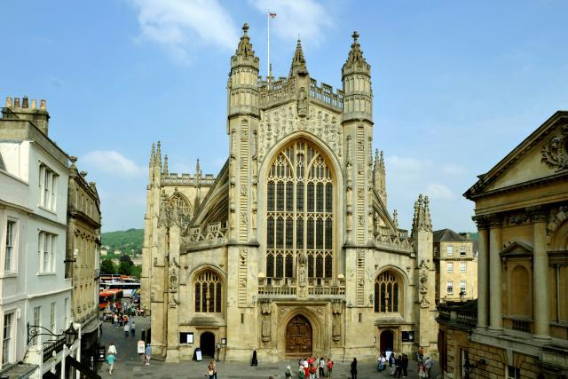

Visiting Bath Abbey

A visual story to help you plan your visit

When I arrive at Bath Abbey I will use this door to go in. The courtyard I will walk through might be noisy with buskers and people, but it will be quieter inside.

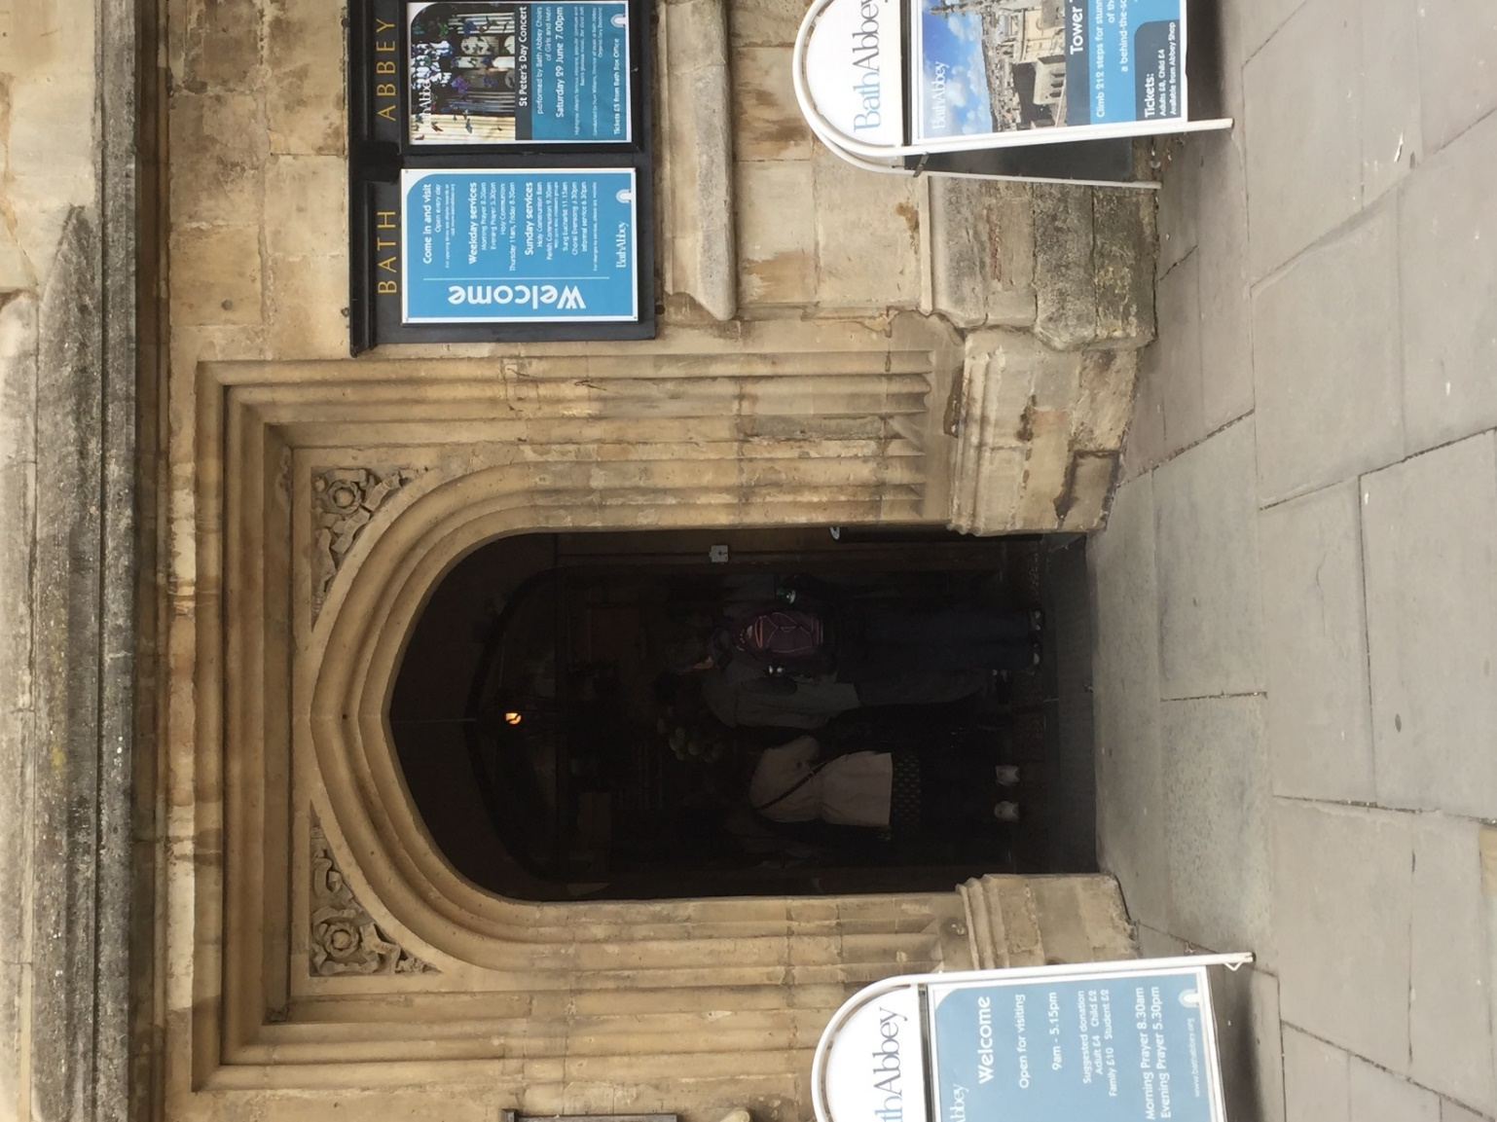

If this entrance is busy I can enter through the shop. I need to go right → and I will see the entrance.
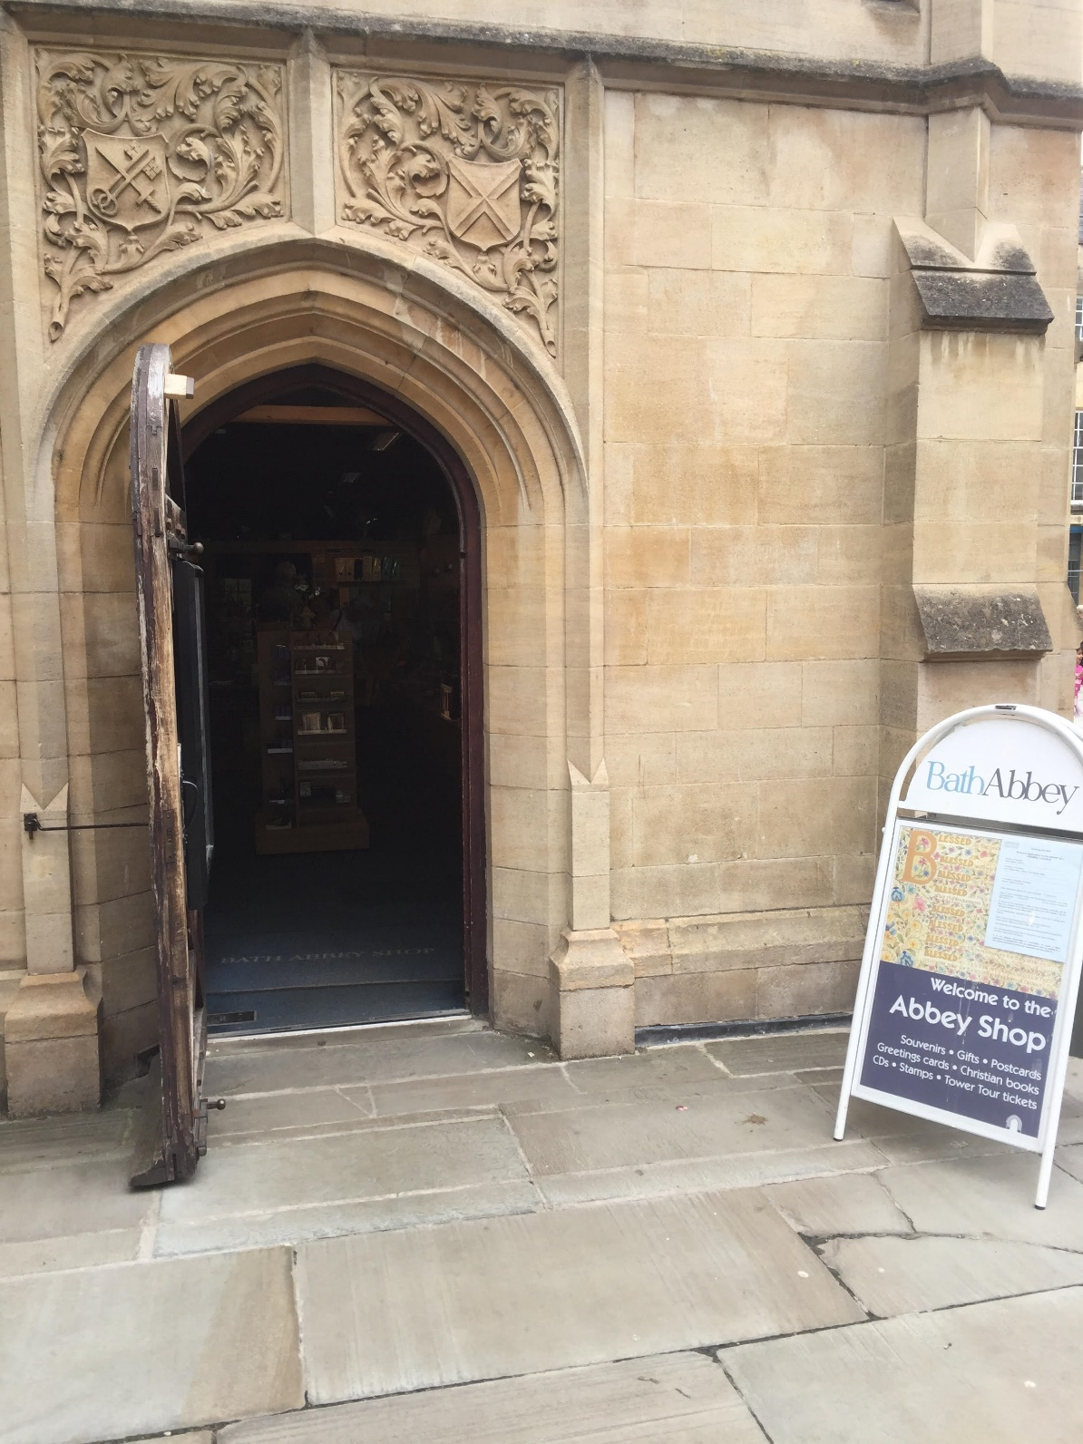

There is a sign outside that tells me when I can go in the Abbey and when there are services. I can join the services if I want to.

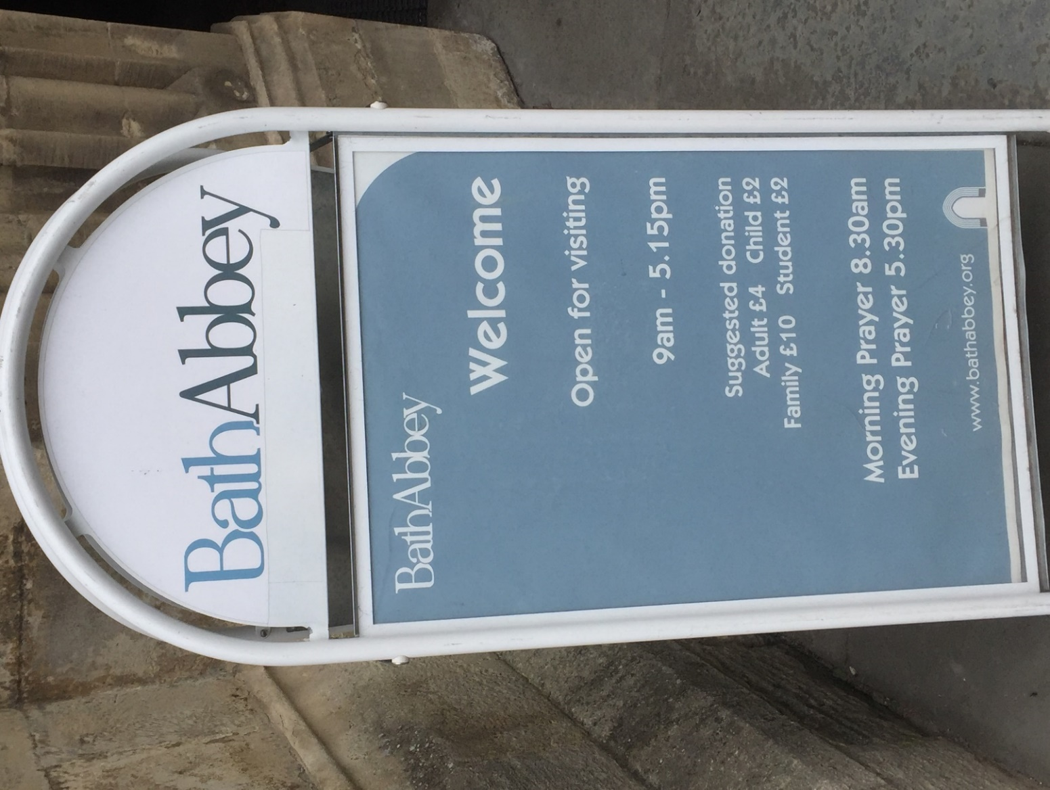

When I go in I will see a font filled with flowers and two desks. It might be noisy here with people waiting to go in.

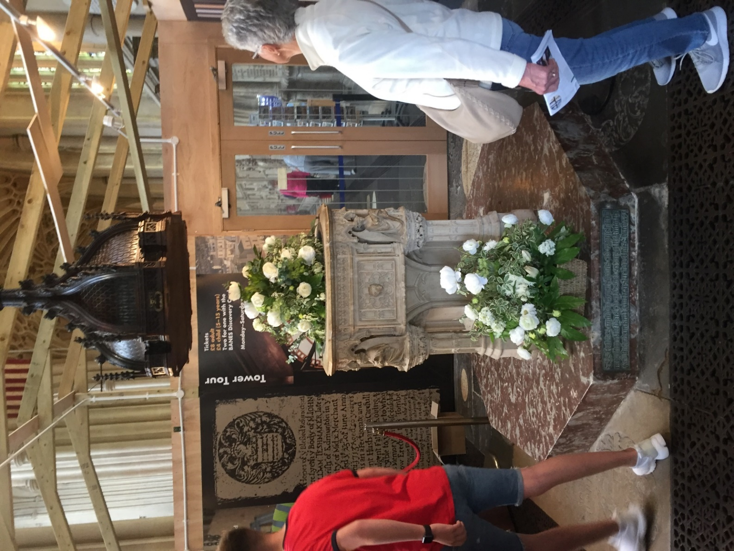

I will see volunteers and staff inside the Abbey. They will wear blue lanyards that say Bath Abbey on them and I can ask them questions and for help.

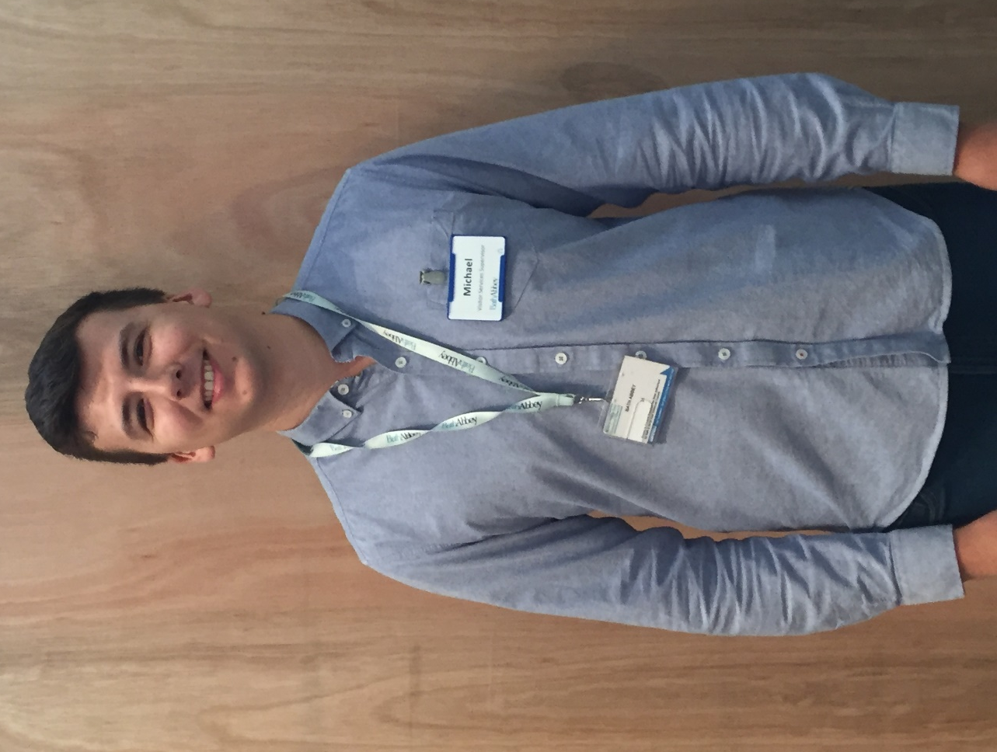

There are two desks with volunteers who can give me information about the Abbey. This is also where I can make my donation to go in.
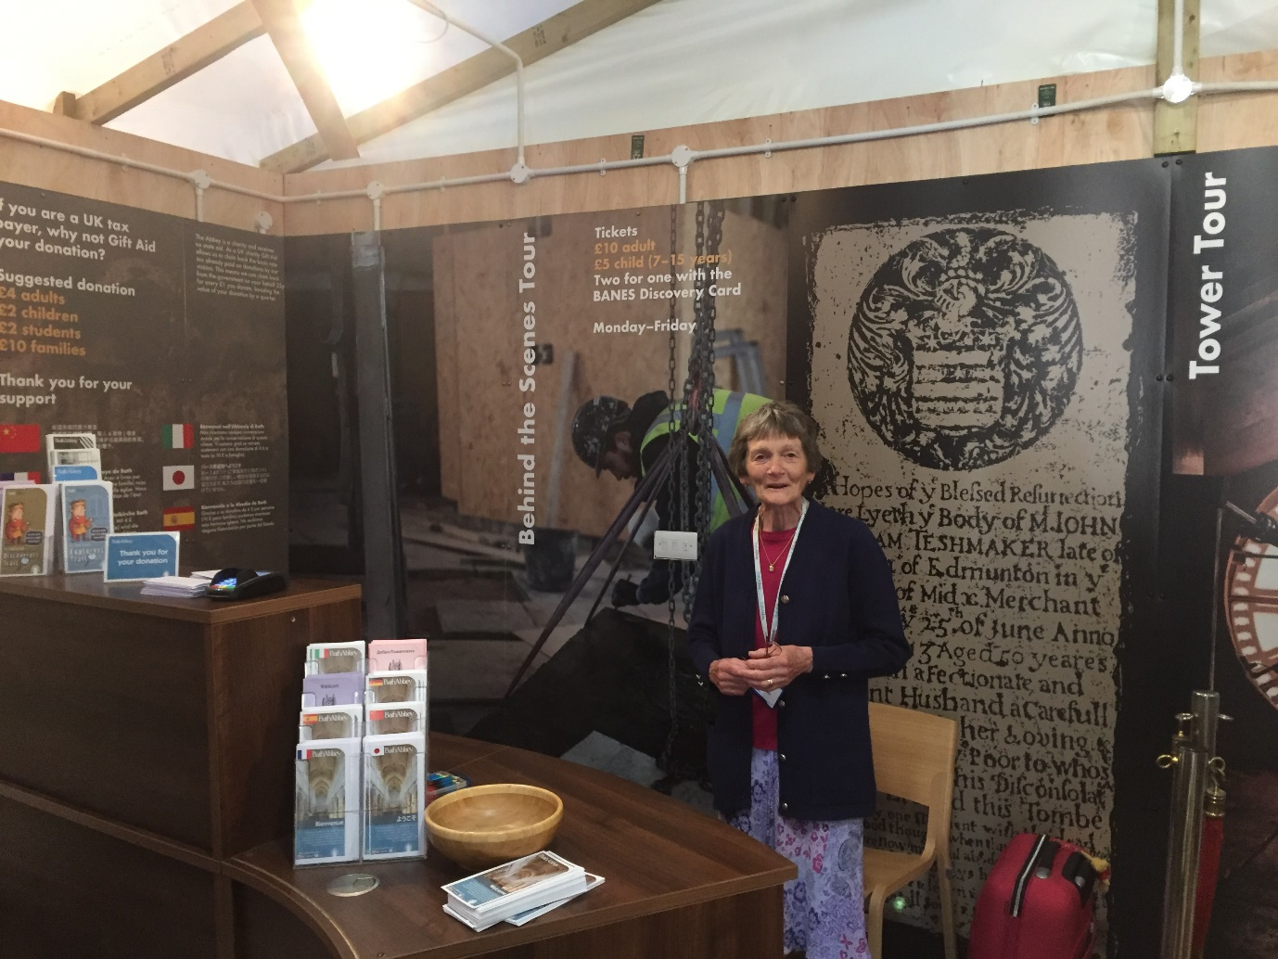

The volunteers can give me information leaflets and a family quiz if I want them.
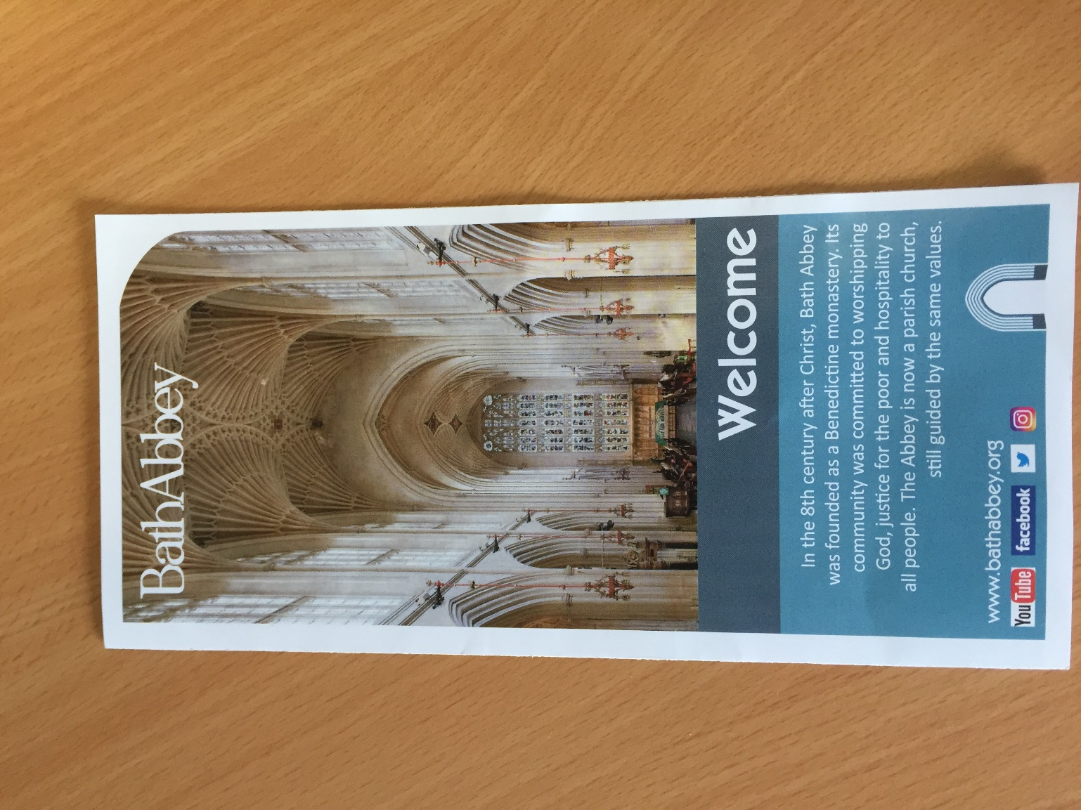
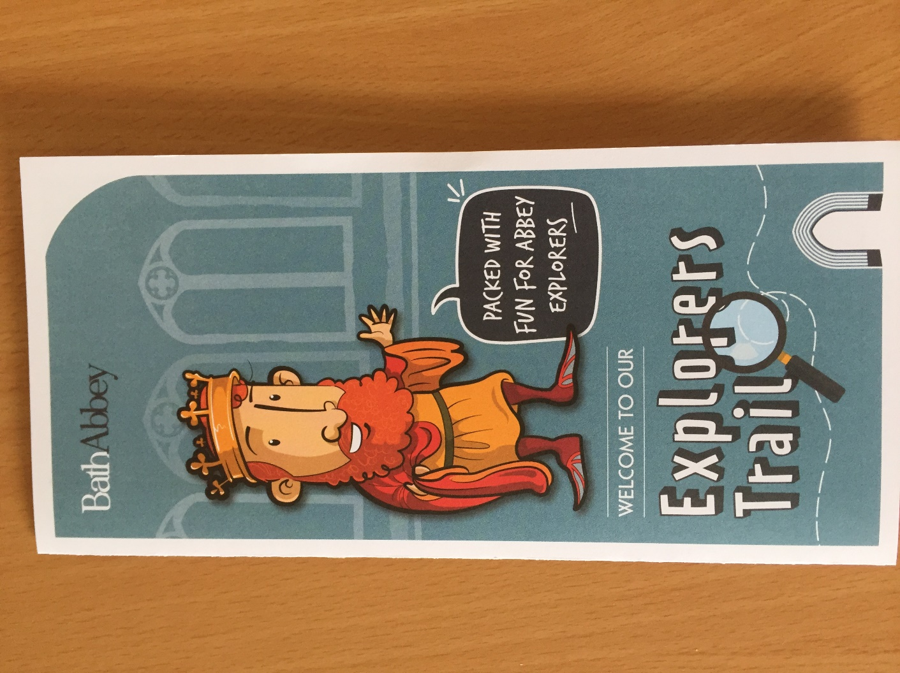

I can also wear these to block out some sounds if it is too noisy. I can ask the volunteers at the desk for these.
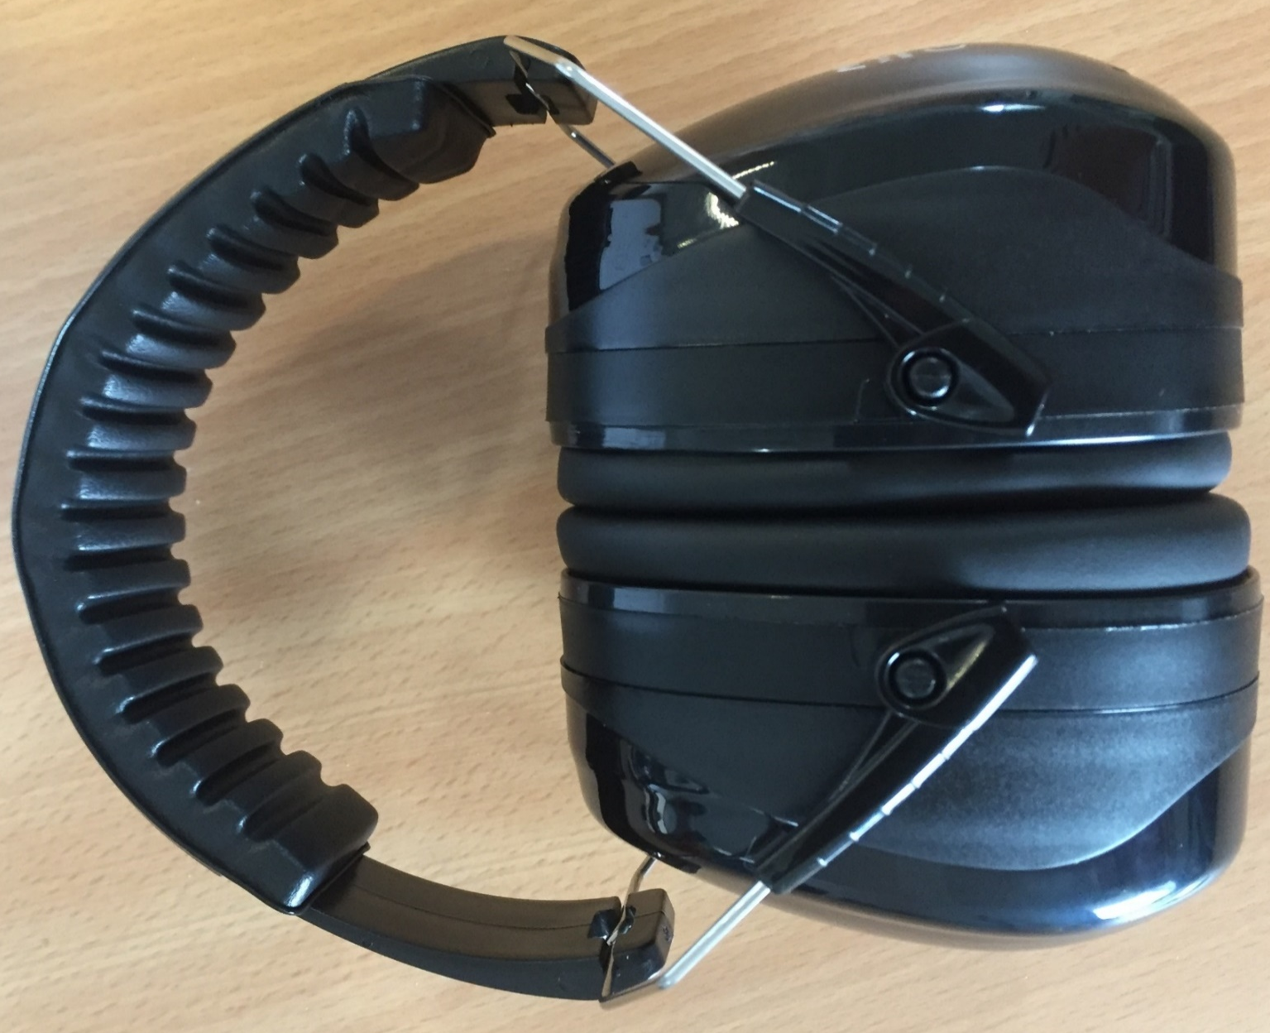

I have to push on the next set of doors and turn right → to get to the rest of the building. This is due to building works going on inside the Abbey and it might be noisy sometimes.
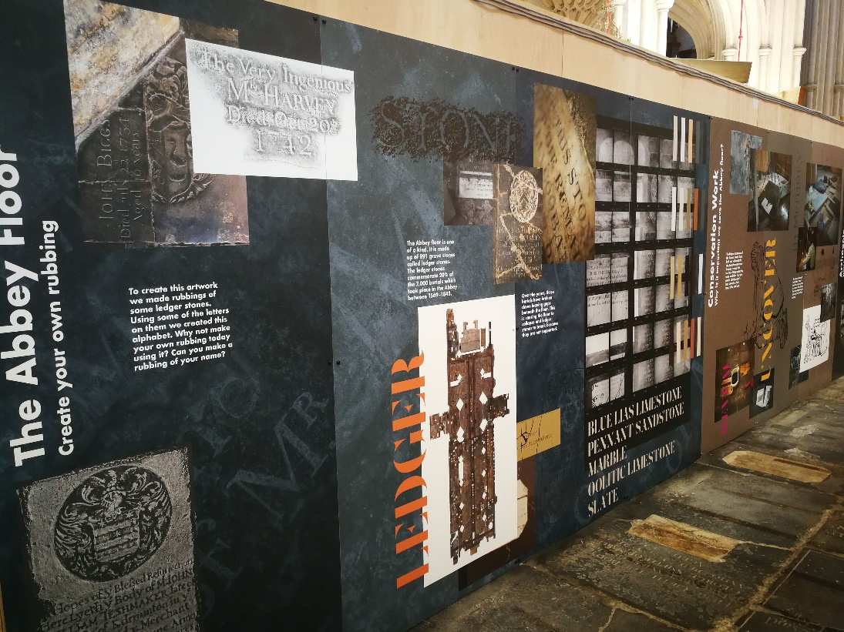
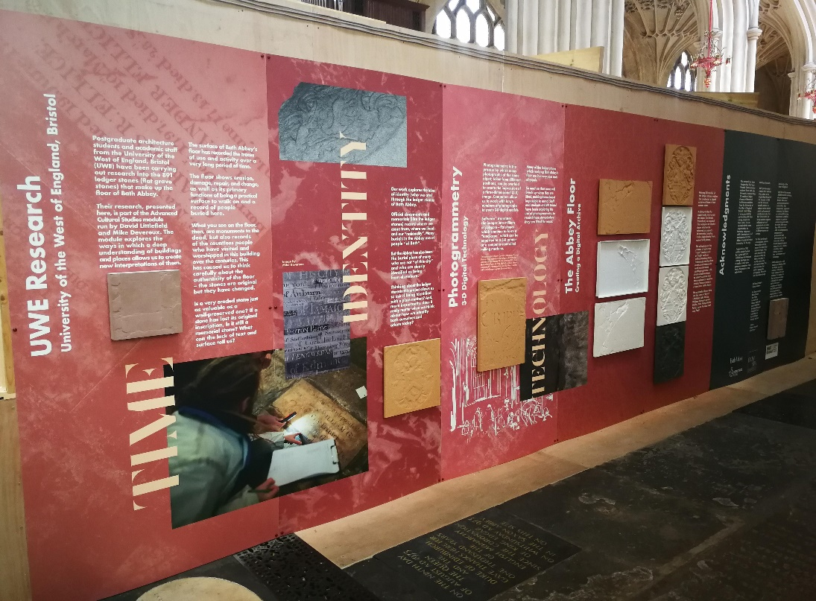

I won’t be able to see all the Abbey due to the building works. The parts I can’t access have these boards in front of them.
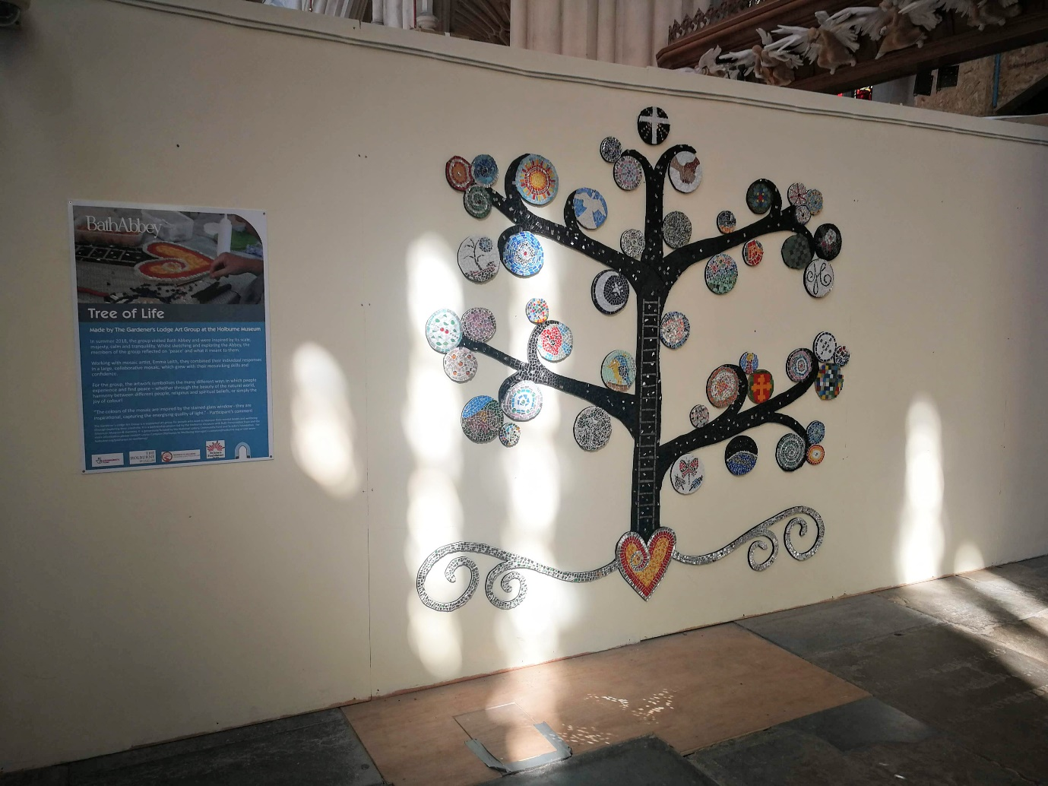

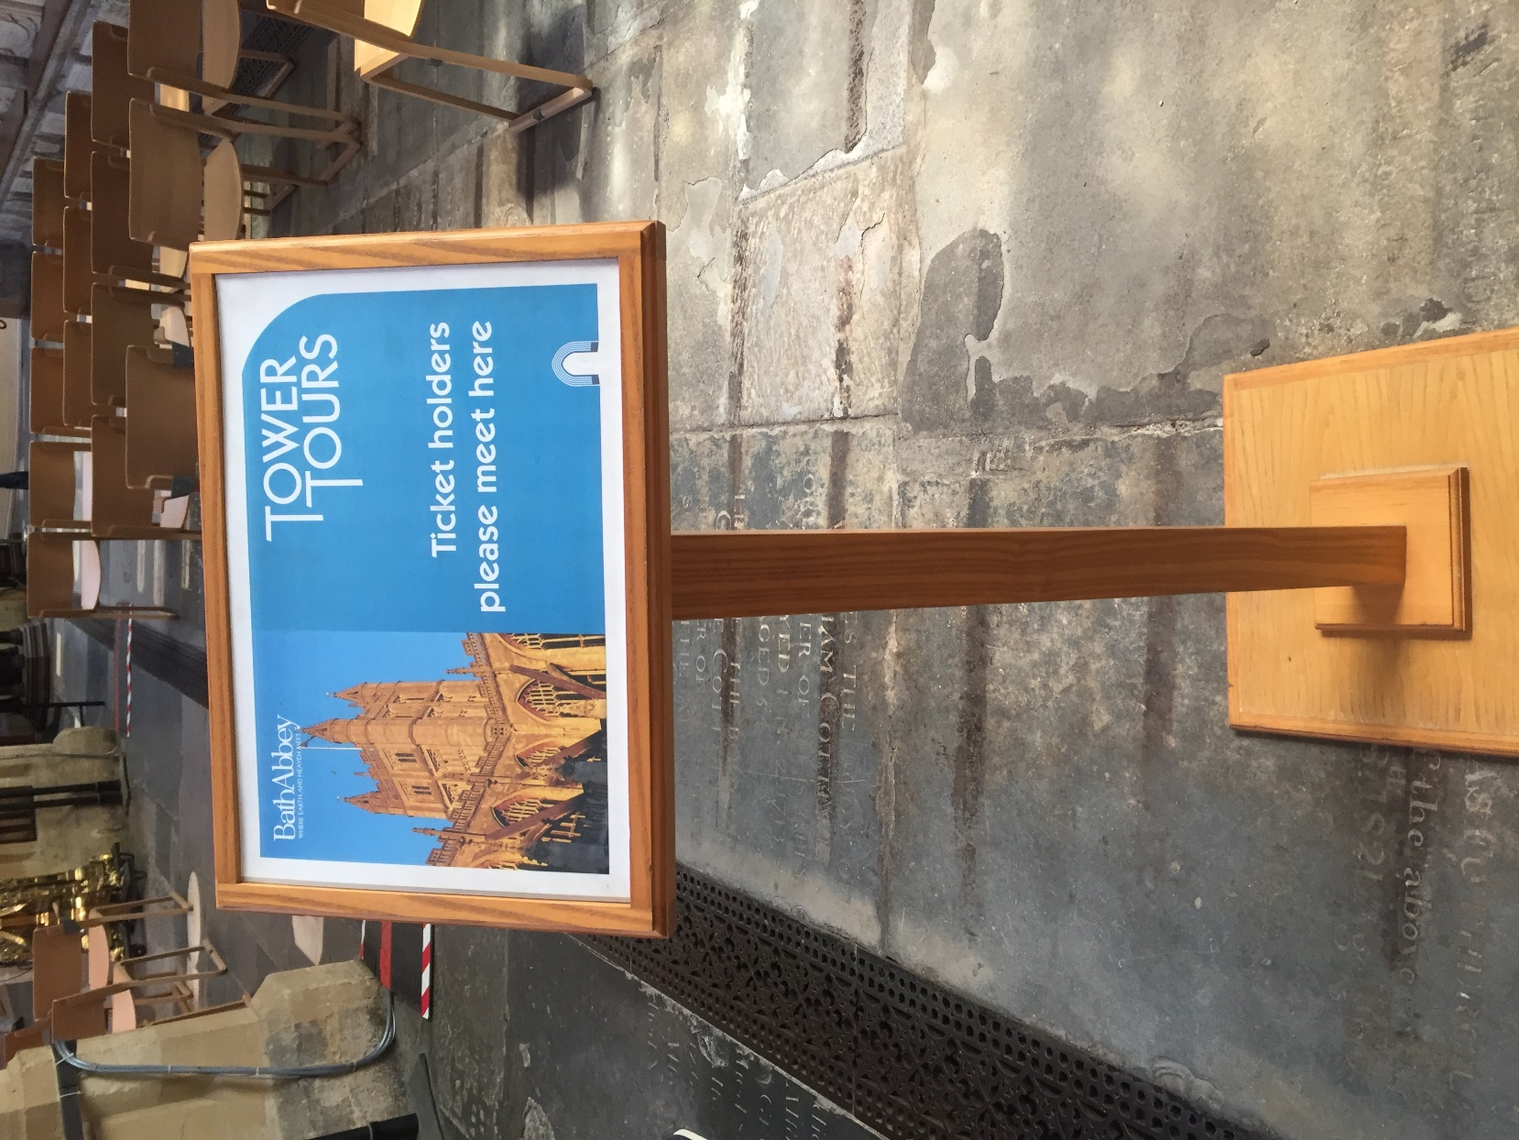
I can go on a tour up 212 steps to the top of the tower. I can buy a ticket in the shop or at the entrance. I need to sit near this stand where the guide will come and collect me.

Inside the Abbey the floor and walls are covered with plaques and writing. I can stop and read these, but I need to be careful as it might be uneven in places.

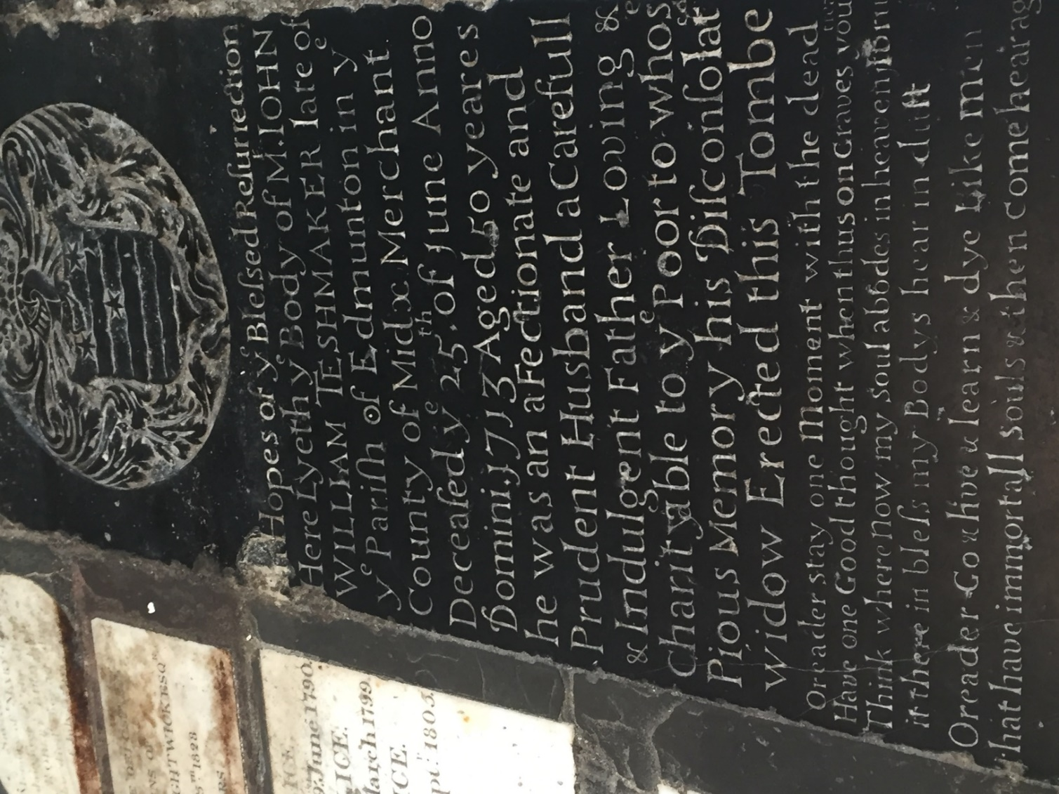

There is some different flooring at different points. I need to watch my feet to make sure I don’t trip.

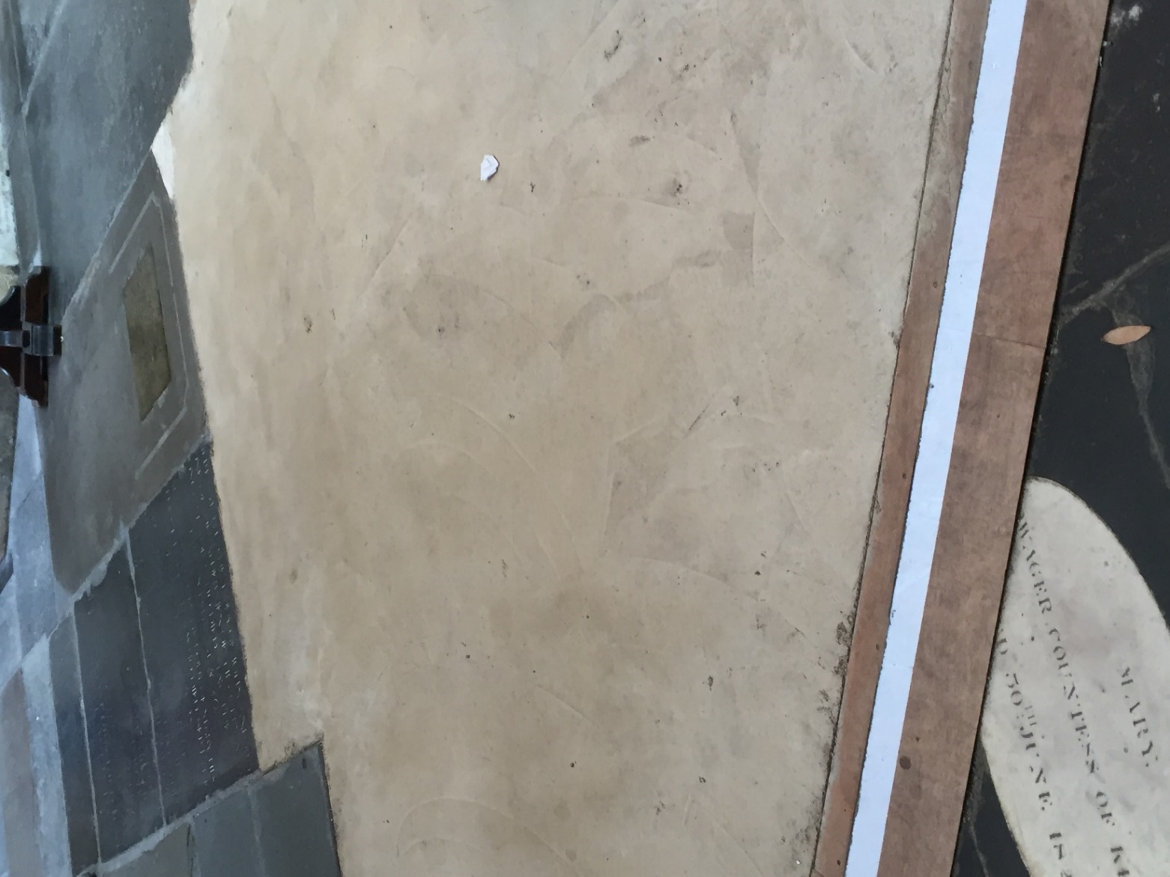

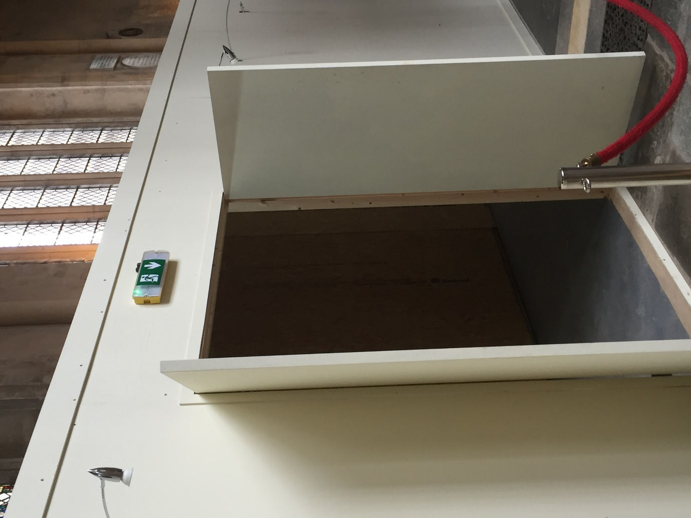
These are the signs I need to follow with my companion if there is an emergency.

There are lots of chairs that I can sit down if I want to all the way through the Abbey.
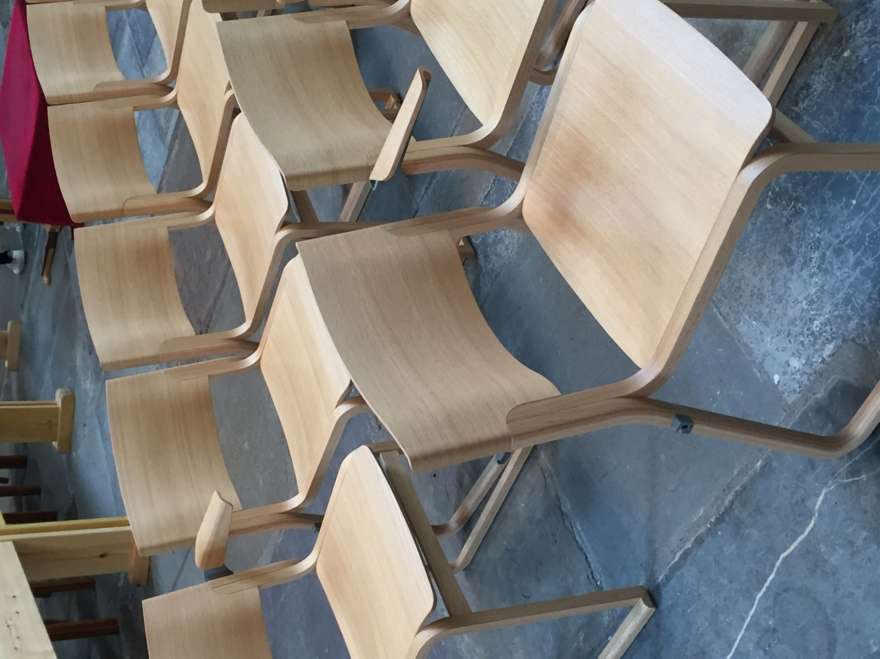

I can look up and see the beautiful fan-vaulted ceiling.
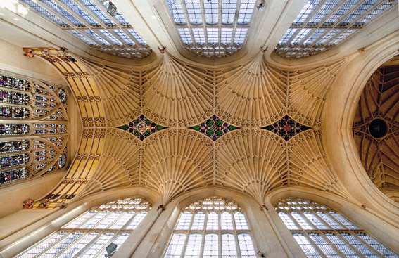

I can also see the Diptychs Exhibition on the left-hand side of the East End.

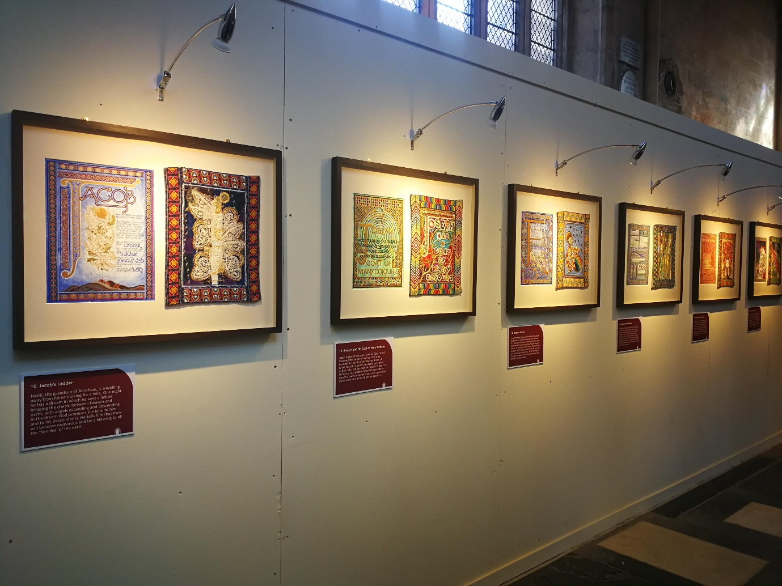

I can go to the East End of the Church. I have to turn around now and go back the way I came in order to leave.
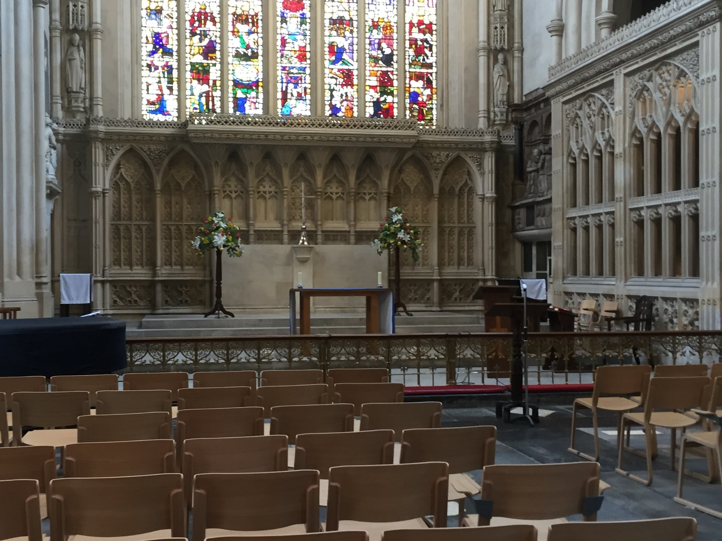

I can light a candle with my companion if I would like to.
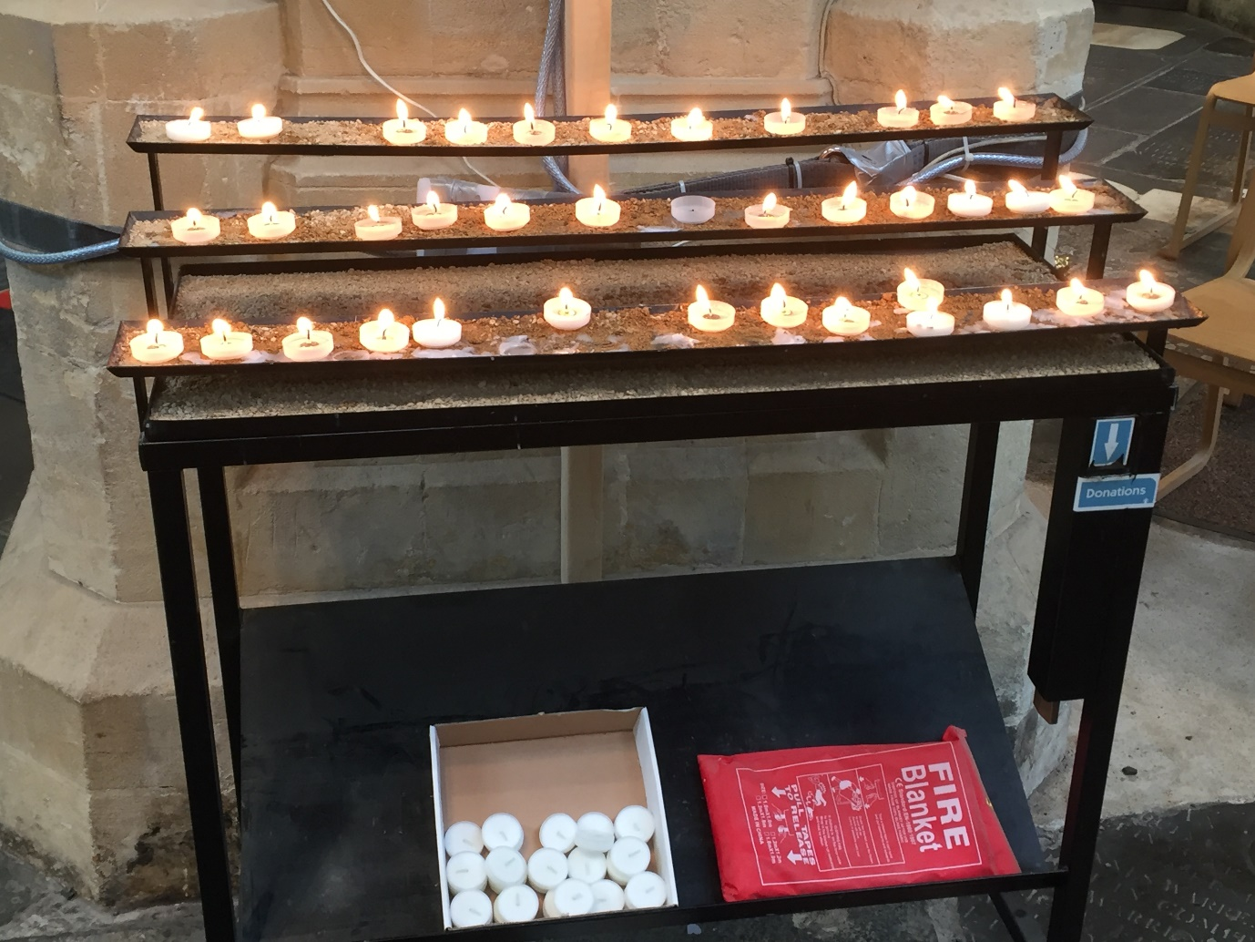

I can write a prayer if I would like to.
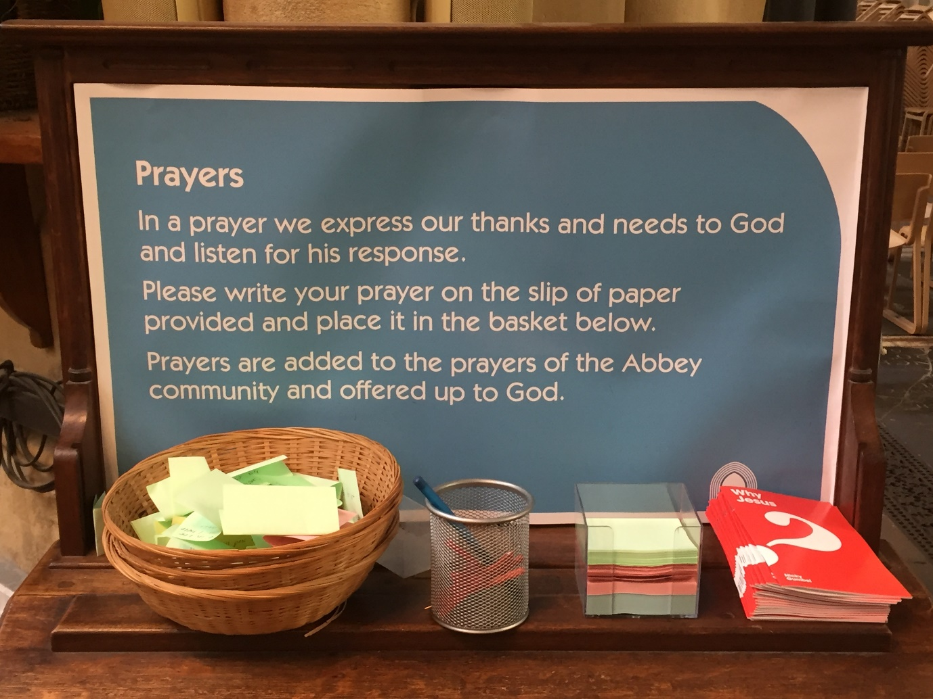

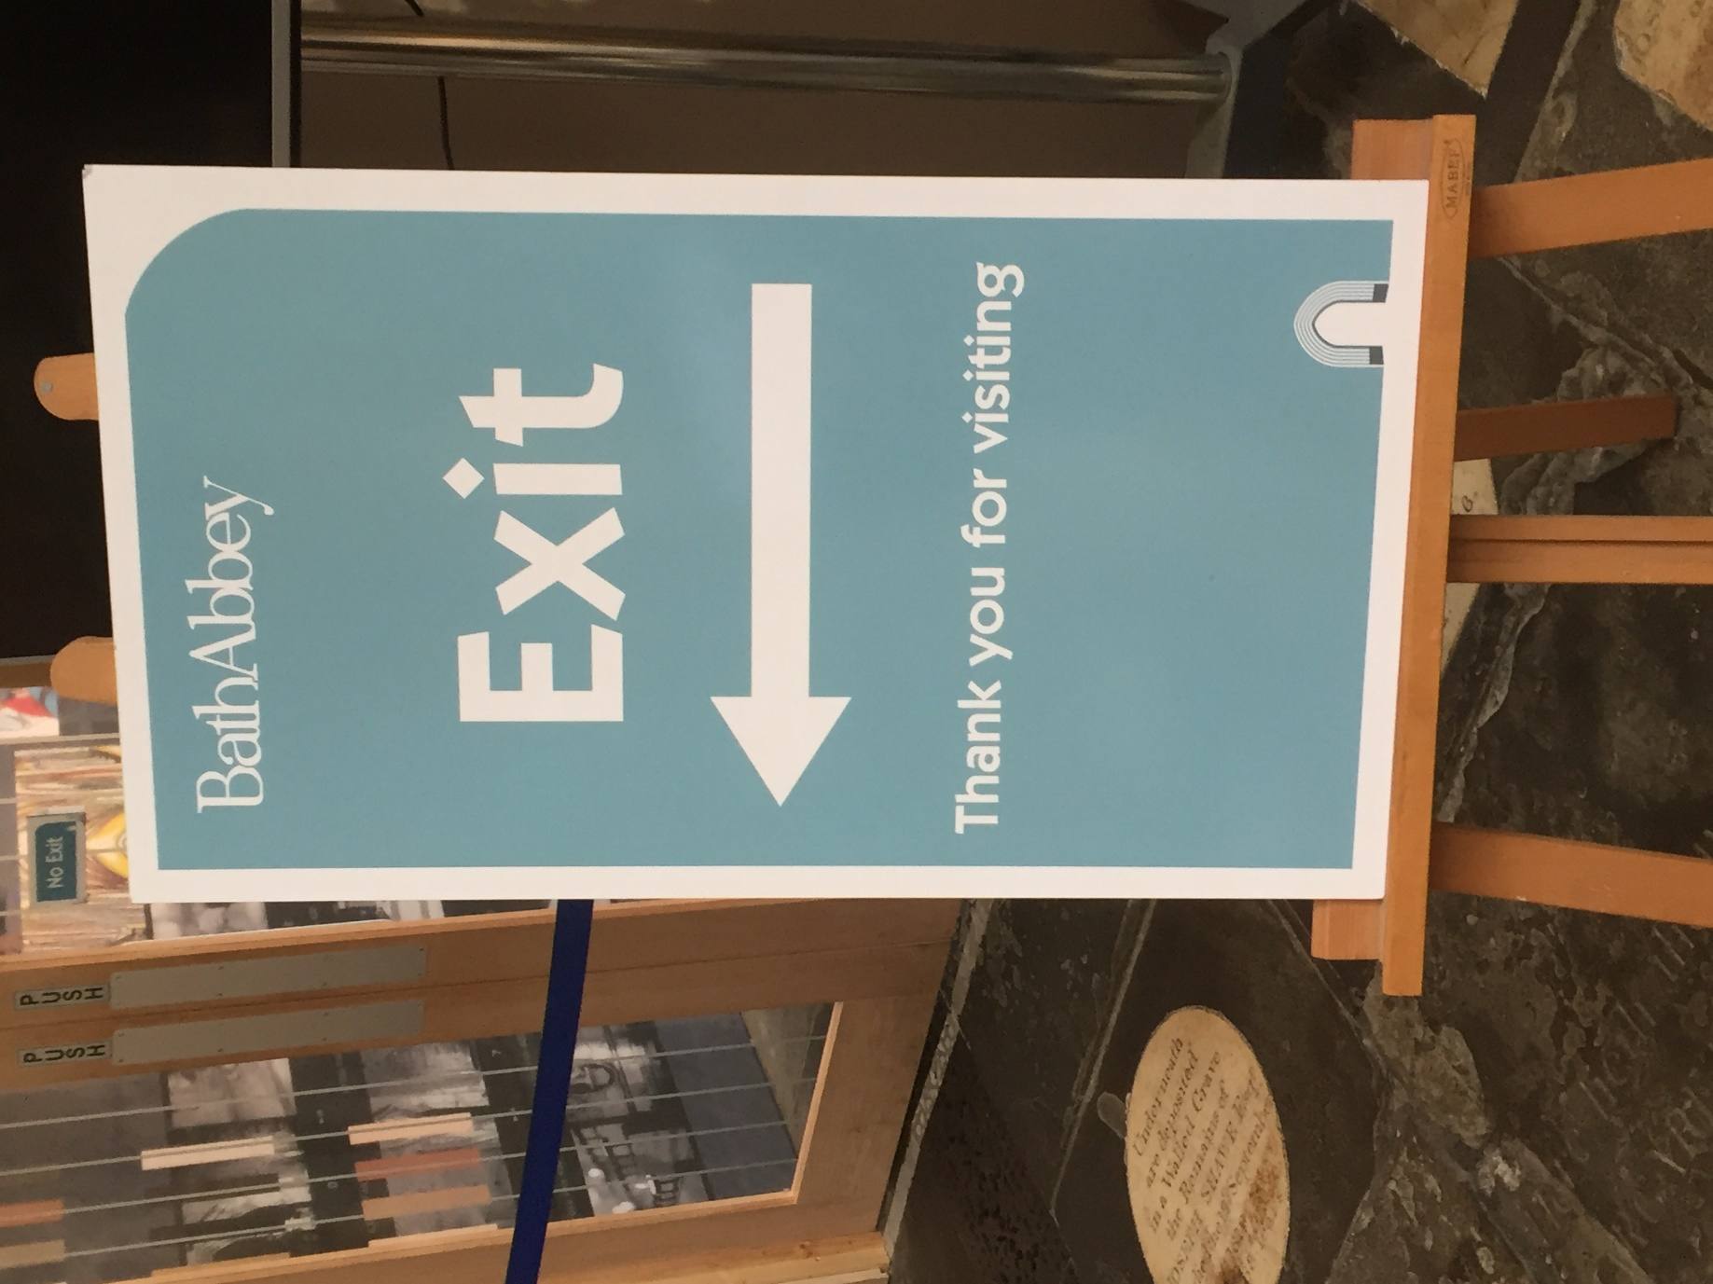
I can follow this sign to get out of the Abbey.

I will see this stand of books on my way out. I can look and buy one if I would like to.
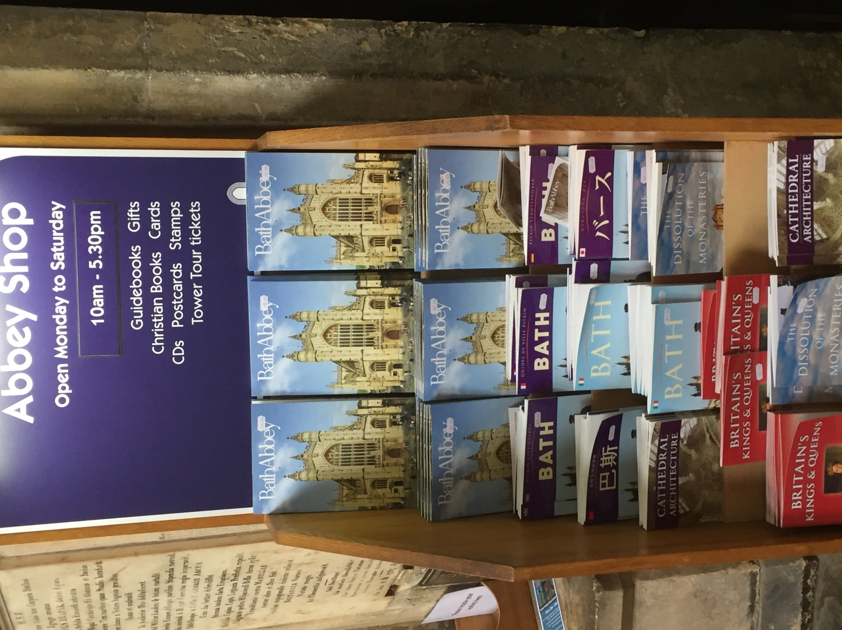

I can exit by going through the Abbey shop. This is the entrance I will see.

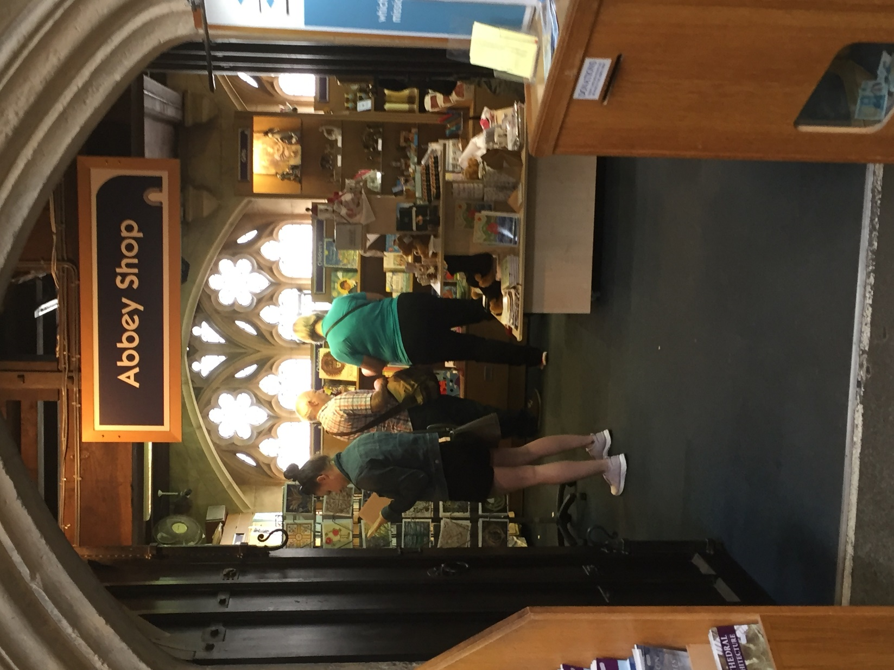

This is the shop. I can buy a souvenir from here.
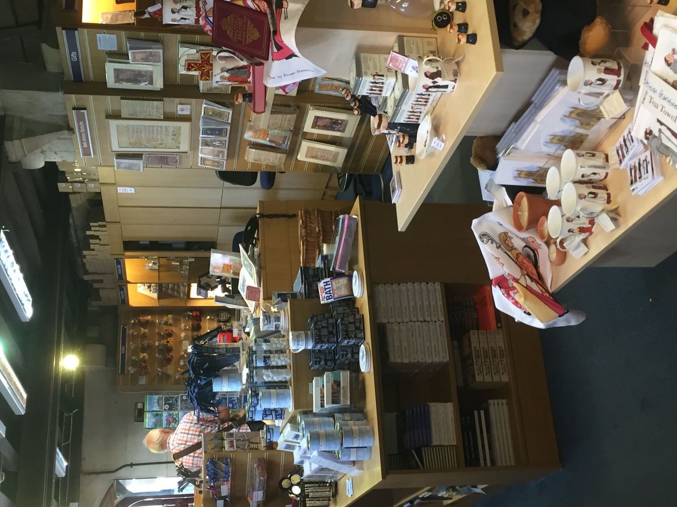

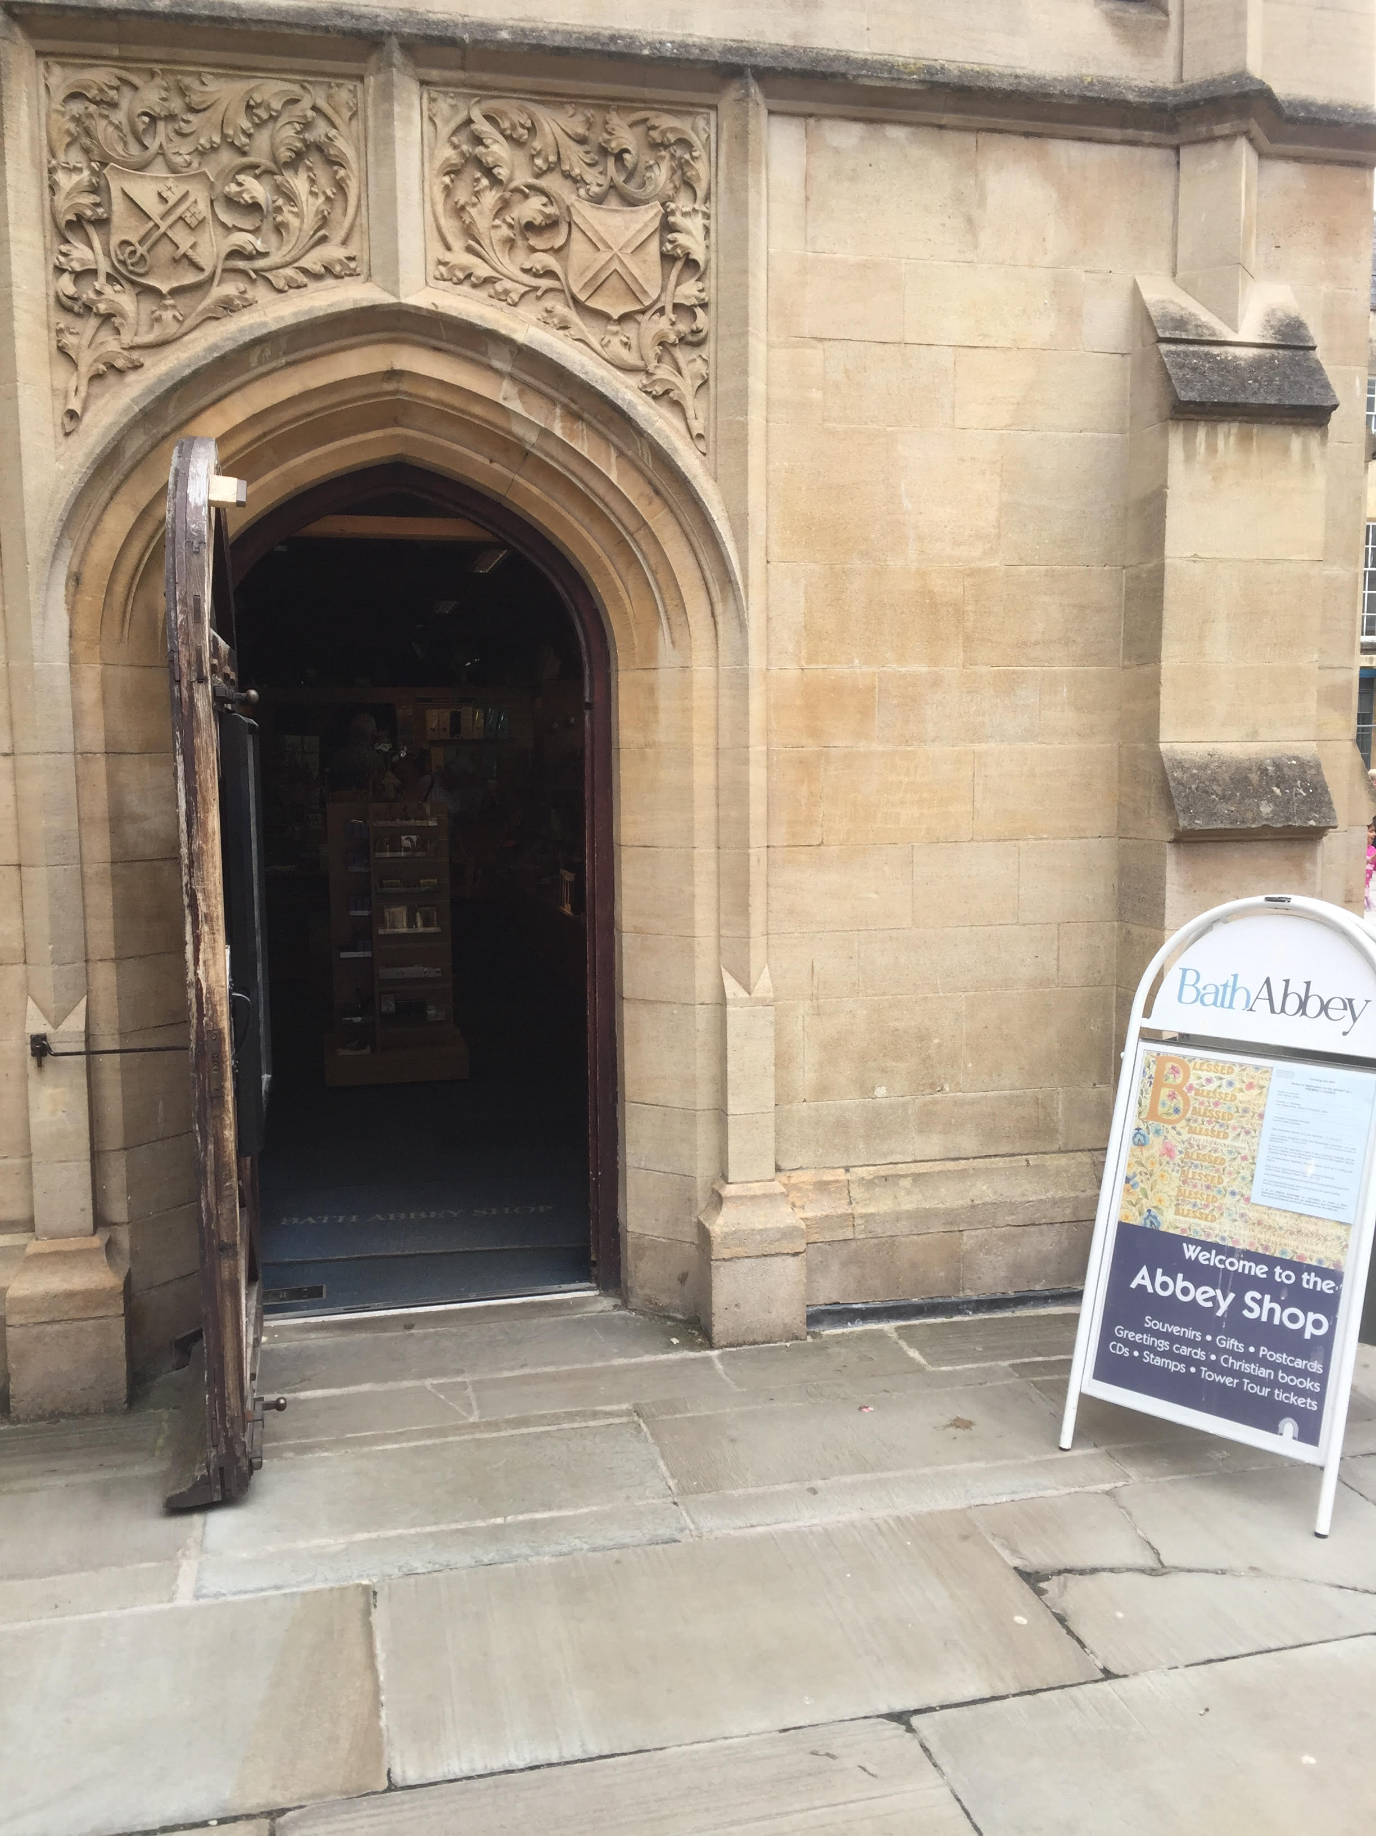
This is the exit for the shop.

We hope you enjoyed your visit to Bath Abbey!
You can draw a picture below of your favourite part.

